

**VIVEKANANDA INSTITUTE OF PROFESSIONAL STUDIES - TECHNICAL CAMPUS**

**Grade A++ Accredited Institution by NAAC**

NBA Accredited for MCA Programme; Recognized under Section 2(f) by UGC;

Affiliated to GGSIP University, Delhi; Recognized by Bar Council of India and AICTE

An ISO 9001:2015 Certified Institution

**SCHOOL OF ENGINEERING & TECHNOLOGY**

**B. Tech Programme: B. Tech AI-ML (A)**

**Course Title: Data Structures Lab**

**Course Code: AIML-201**

**Submitted To: Submitted By:**

**Ms. Nishi Jain Name: Kunsh Sabharwal**

**Assistant Professor Enrolment No: 01117711623**

**VIVEKANANDA INSTITUTE OF PROFESSIONAL STUDIES - TECHNICAL CAMPUS**

**Grade A++ Accredited Institution by NAAC**

NBA Accredited for MCA Programme; Recognized under Section 2(f) by UGC;

Affiliated to GGSIP University, Delhi; Recognized by Bar Council of India and AICTE

An ISO 9001:2015 Certified Institution

**SCHOOL OF ENGINEERING & TECHNOLOGY**

**VISION OF INSTITUTE**

To be an educational institute that empowers the field of engineering to build a sustainable future by providing quality education with innovative practices that supports people, planet and profit.

**MISSION OF INSTITUTE**

To groom the future engineers by providing value-based education and awakening students' curiosity, nurturing creativity and building  
capabilities to enable them to make significant contributions to the world.

**VIVEKANANDA INSTITUTE OF PROFESSIONAL STUDIES - TECHNICAL CAMPUS**

**Grade A++ Accredited Institution by NAAC**

NBA Accredited for MCA Programme; Recognized under Section 2(f) by UGC;

Affiliated to GGSIP University, Delhi; Recognized by Bar Council of India and AICTE

An ISO 9001:2015 Certified Institution

**SCHOOL OF ENGINEERING & TECHNOLOGY**

**INDEX**

|  |  |  |  |  |  |  |  |  |
| --- | --- | --- | --- | --- | --- | --- | --- | --- |
| S.No. | Experiment | Date | Marks | | | Remarks | Updated Marks | Faculty Signature |
| Laboratory Assessment (15 Marks) | Class Participation (5 Marks) | Viva (5 Marks) |  |  |  |
| 1. |  |  |  |  |  |  |  |  |
| 2. |  |  |  |  |  |  |  |  |
| 3. |  |  |  |  |  |  |  |  |

**VIVEKANANDA INSTITUTE OF PROFESSIONAL STUDIES - TECHNICAL CAMPUS**

**Grade A++ Accredited Institution by NAAC**

NBA Accredited for MCA Programme; Recognized under Section 2(f) by UGC;

Affiliated to GGSIP University, Delhi; Recognized by Bar Council of India and AICTE

An ISO 9001:2015 Certified Institution

|  |  |  |  |  |  |  |  |  |
| --- | --- | --- | --- | --- | --- | --- | --- | --- |
| S.No. | Experiment | Date | Marks | | | Remarks | Updated Marks | Faculty Signature |
| Laboratory Assessment (15 Marks) | Class Participation (5 Marks) | Viva (5 Marks) |  |  |  |
| 4. |  |  |  |  |  |  |  |  |
| 5. |  |  |  |  |  |  |  |  |
| 6. |  |  |  |  |  |  |  |  |

**SCHOOL OF ENGINEERING & TECHNOLOGY**

**VIVEKANANDA INSTITUTE OF PROFESSIONAL STUDIES - TECHNICAL CAMPUS**

**Grade A++ Accredited Institution by NAAC**

NBA Accredited for MCA Programme; Recognized under Section 2(f) by UGC;

Affiliated to GGSIP University, Delhi; Recognized by Bar Council of India and AICTE

An ISO 9001:2015 Certified Institution

|  |  |  |  |  |  |  |  |  |
| --- | --- | --- | --- | --- | --- | --- | --- | --- |
| S.No. | Experiment | Date | Marks | | | Remarks | Updated Marks | Faculty Signature |
| Laboratory Assessment (15 Marks) | Class Participation (5 Marks) | Viva (5 Marks) |  |  |  |
| 7(a). |  |  |  |  |  |  |  |  |
| 7(b). |  |  |  |  |  |  |  |  |
| 8. |  |  |  |  |  |  |  |  |

**SCHOOL OF ENGINEERING & TECHNOLOGY**

**EXPERIMENT 1(a)**

**Problem statement:** Write a program to implement linear search.

**Algorithm:**

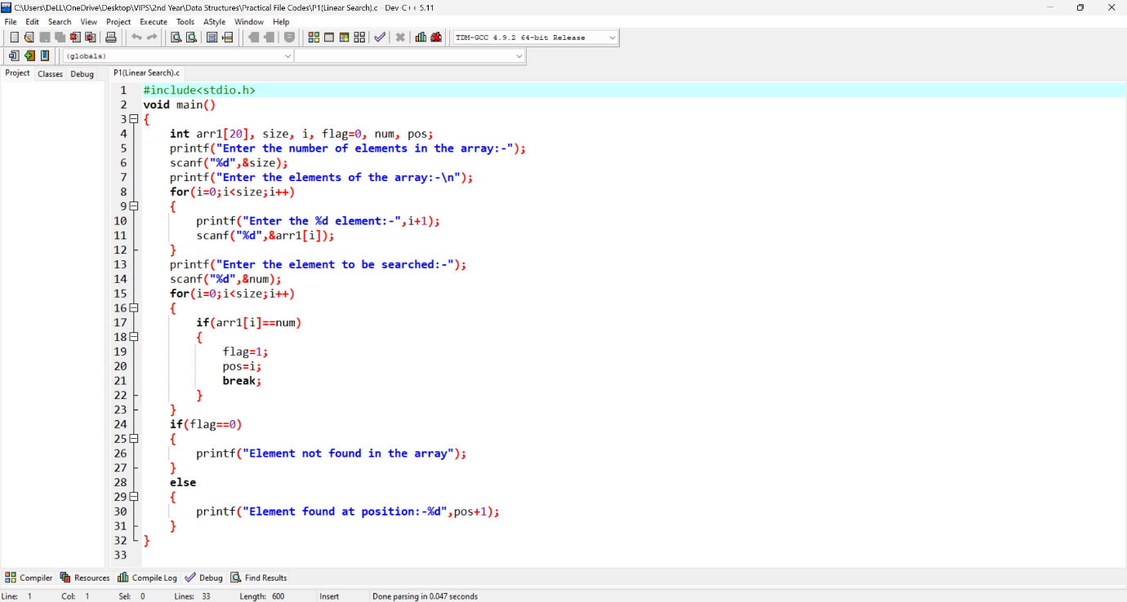**Programming Code:**

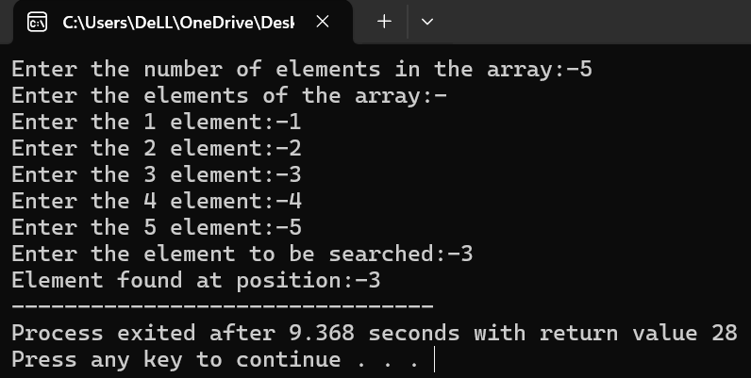**Output:**

**Learning Outcomes:**

**EXPERIMENT 1(b)**

**Problem statement:** Write a program to implement Binary search.

**Algorithm:**

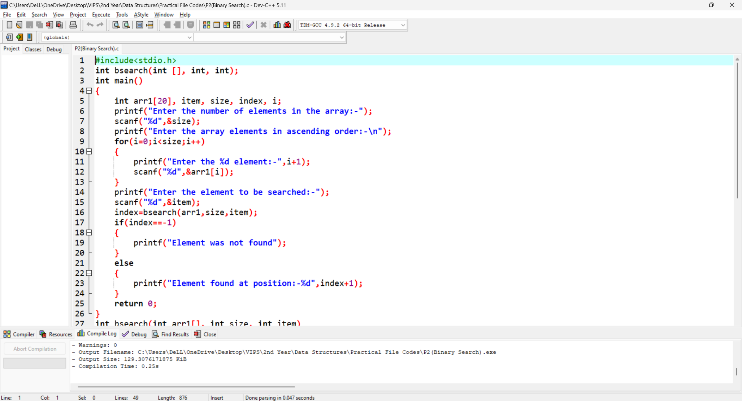**Programming Code:**

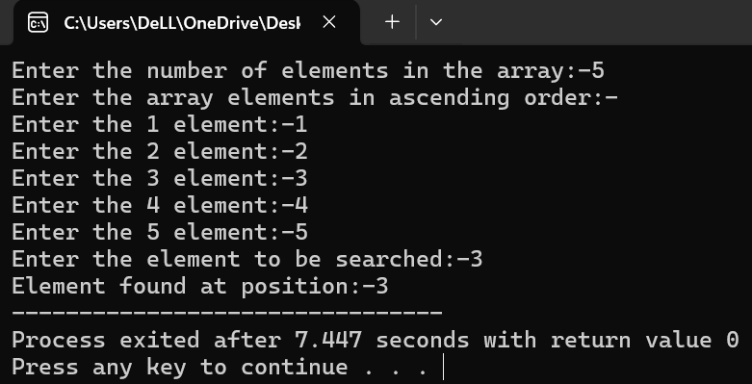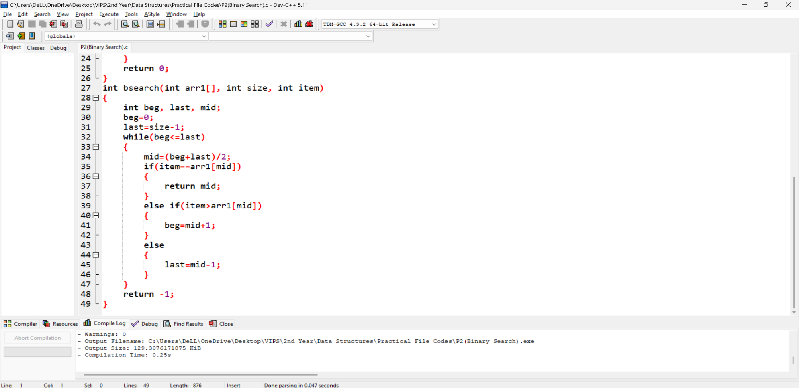**Output:**

**Learning Outcomes:**

**EXPERIMENT 2**

**Problem statement:** Create a stack and perform Peek, Pop, Push and Traverse operations on the stack using an array.

**Algorithm:**

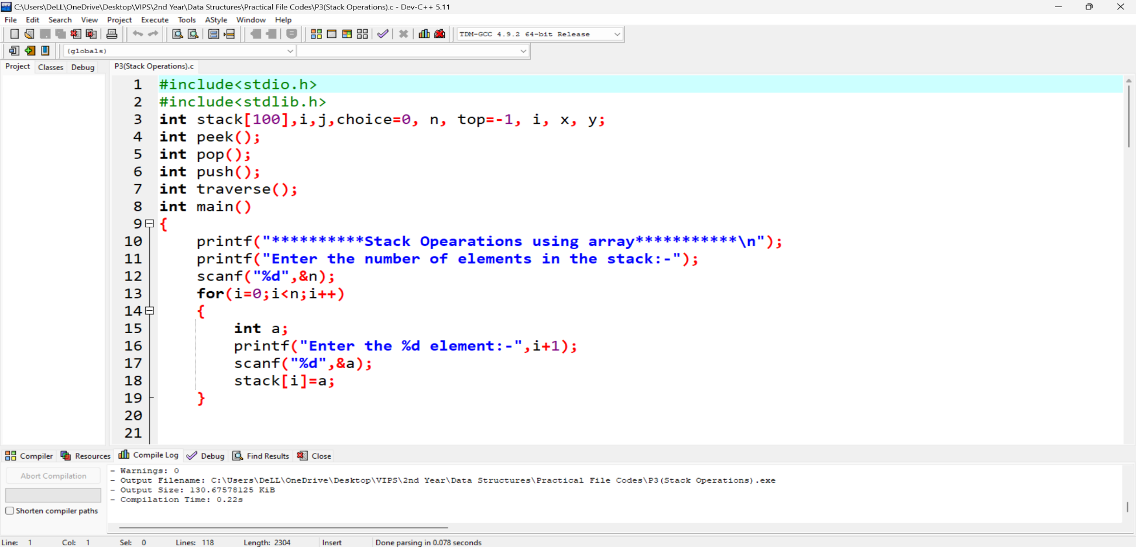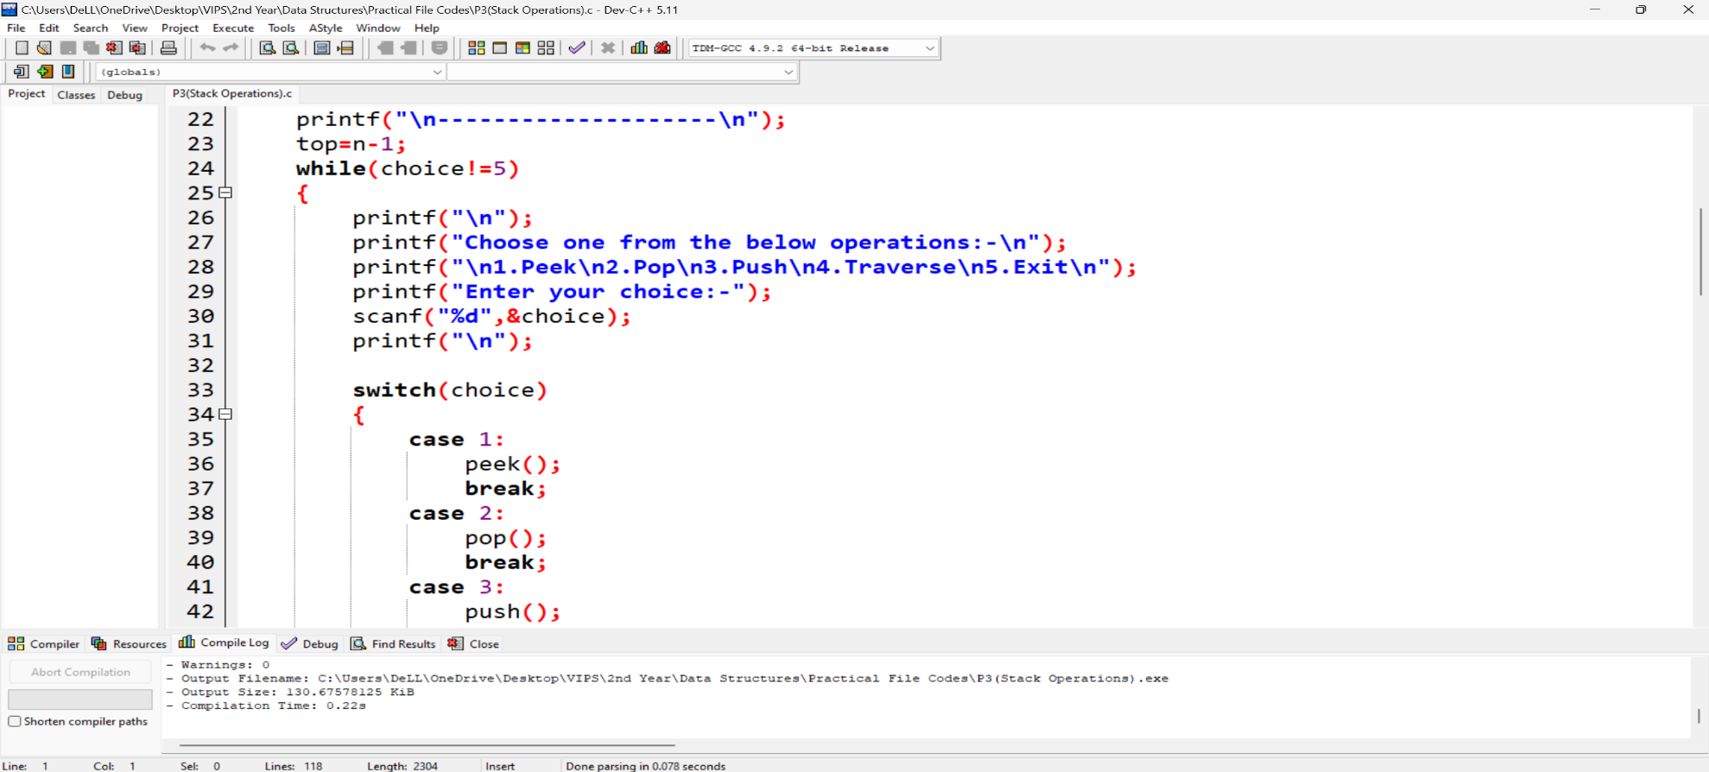**Programming Code:**

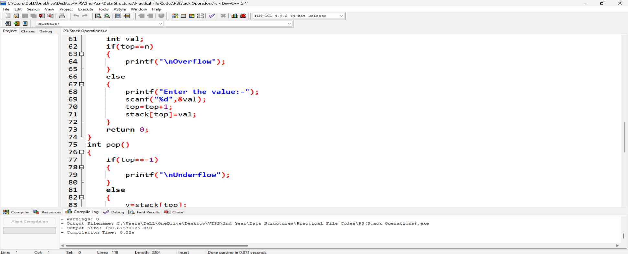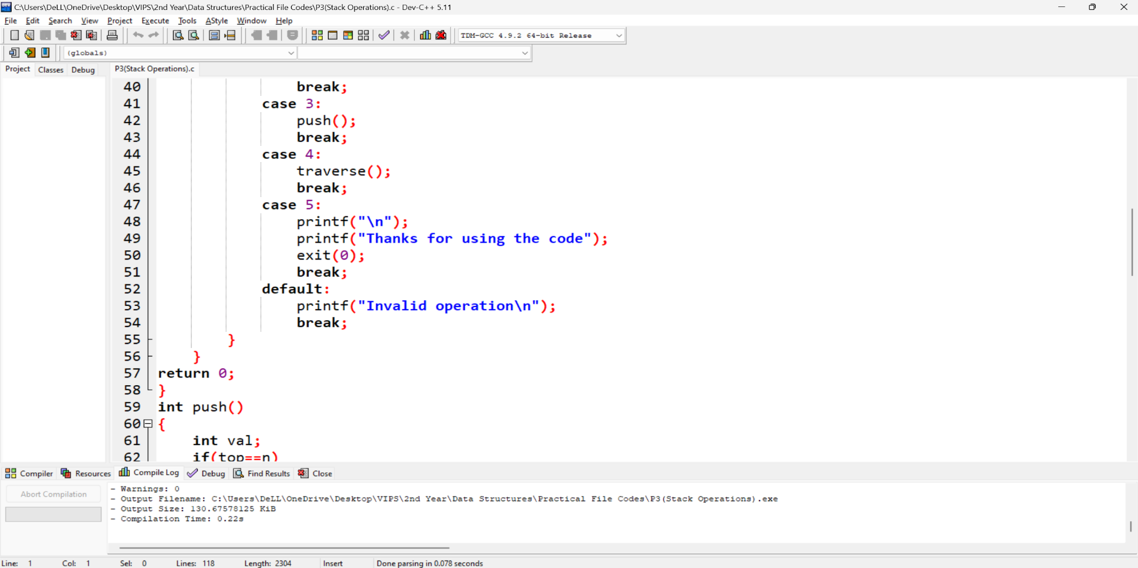

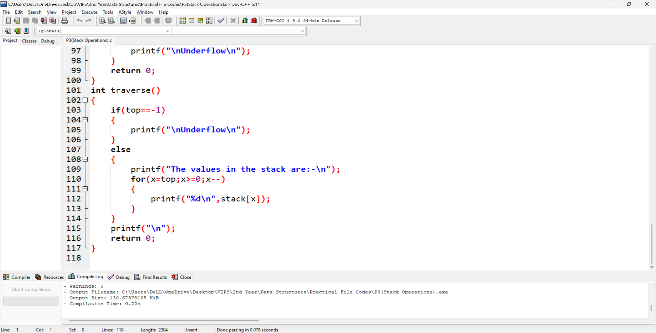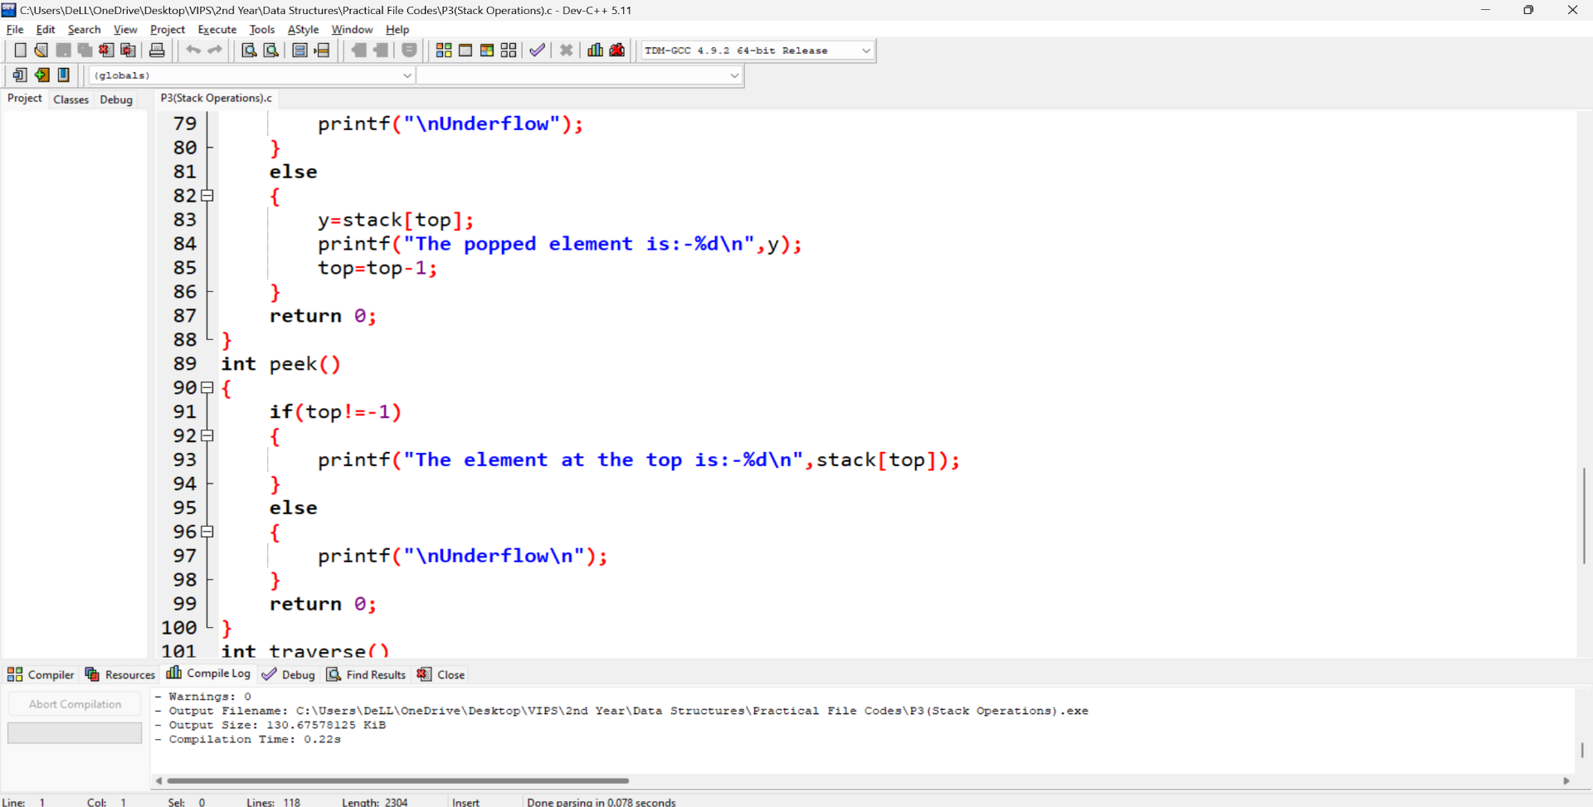

**Output:**

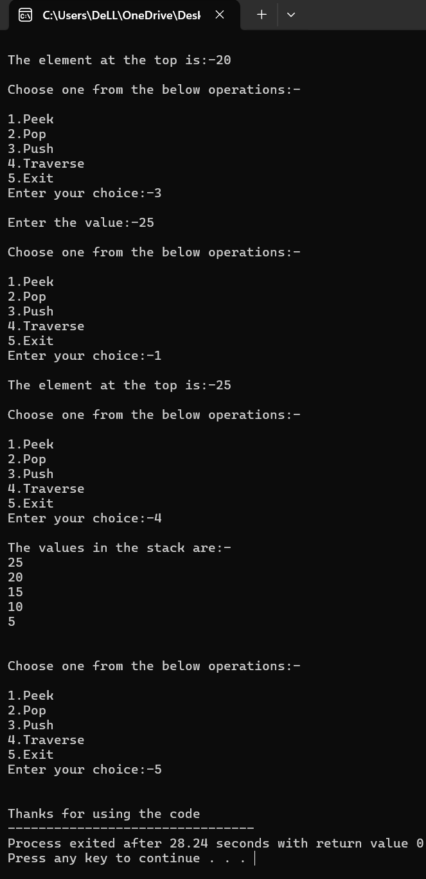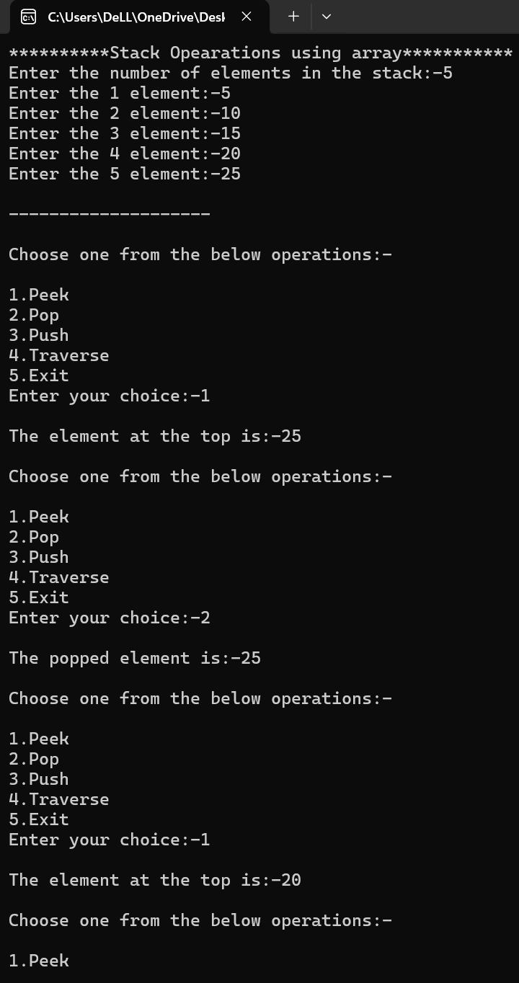

**Learning Outcome:**

**EXPERIMENT 3(a)**

**Problem statement:** Write programs to implement Bubble Sort and Insertion Sort.

**Algorithm:**

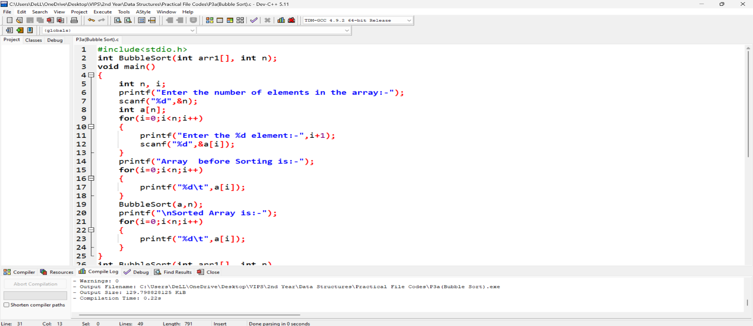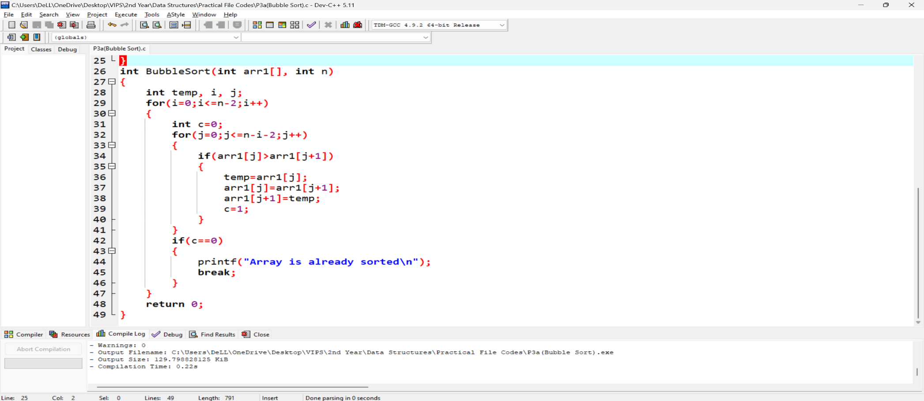**Programming Code:**

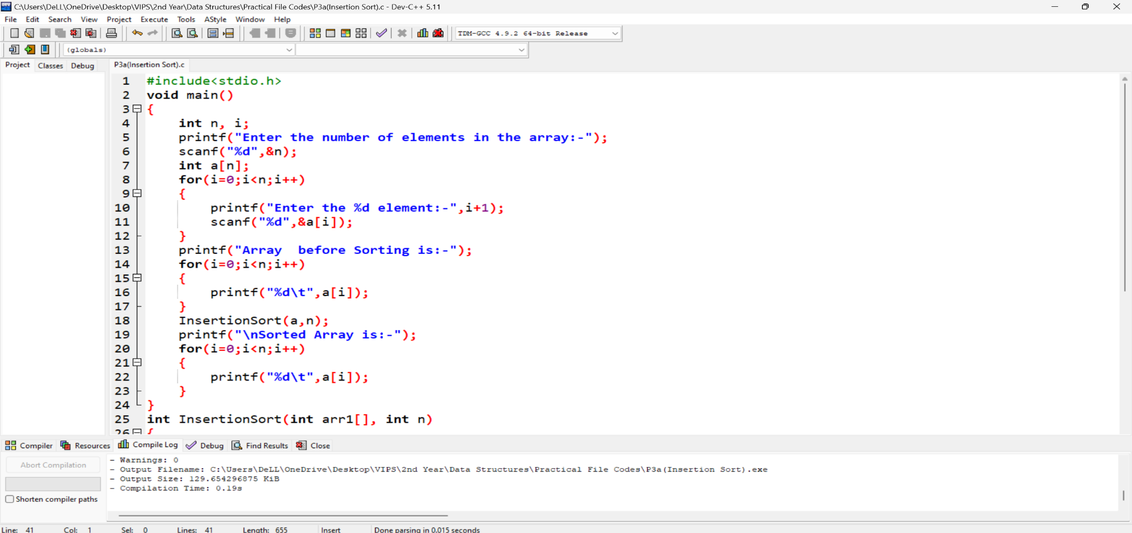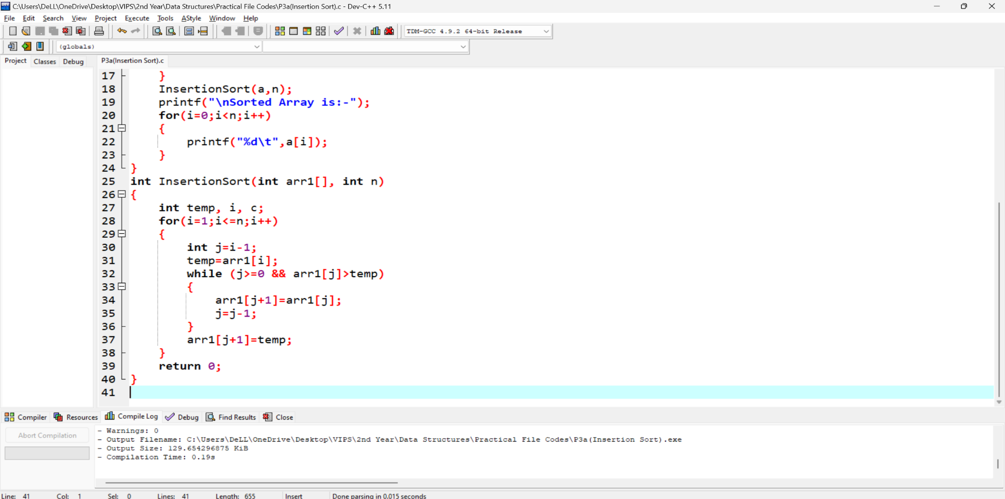

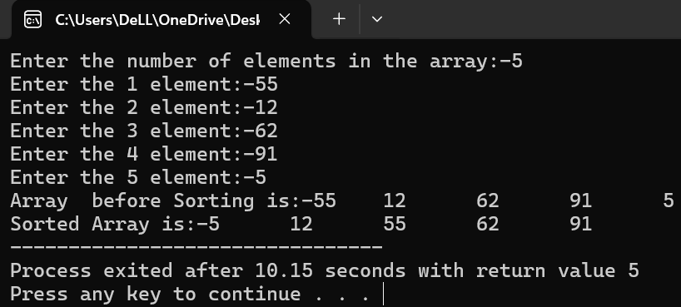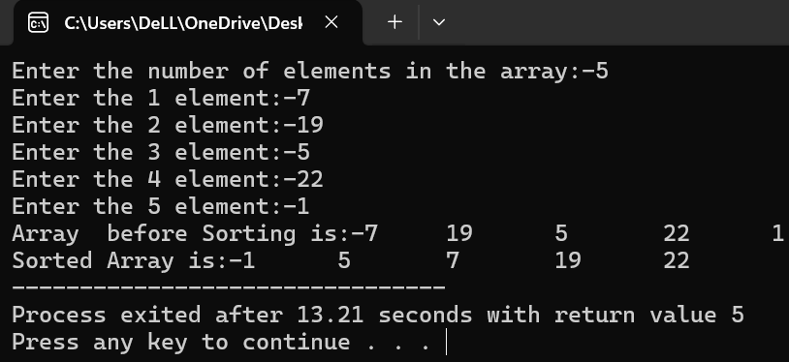**Output:**

**Learning Outcome:**

**EXPERIMENT 3(b)**

**Problem statement:** Write programs to implement Selection Sort and Merge Sort.

**Algorithm:**

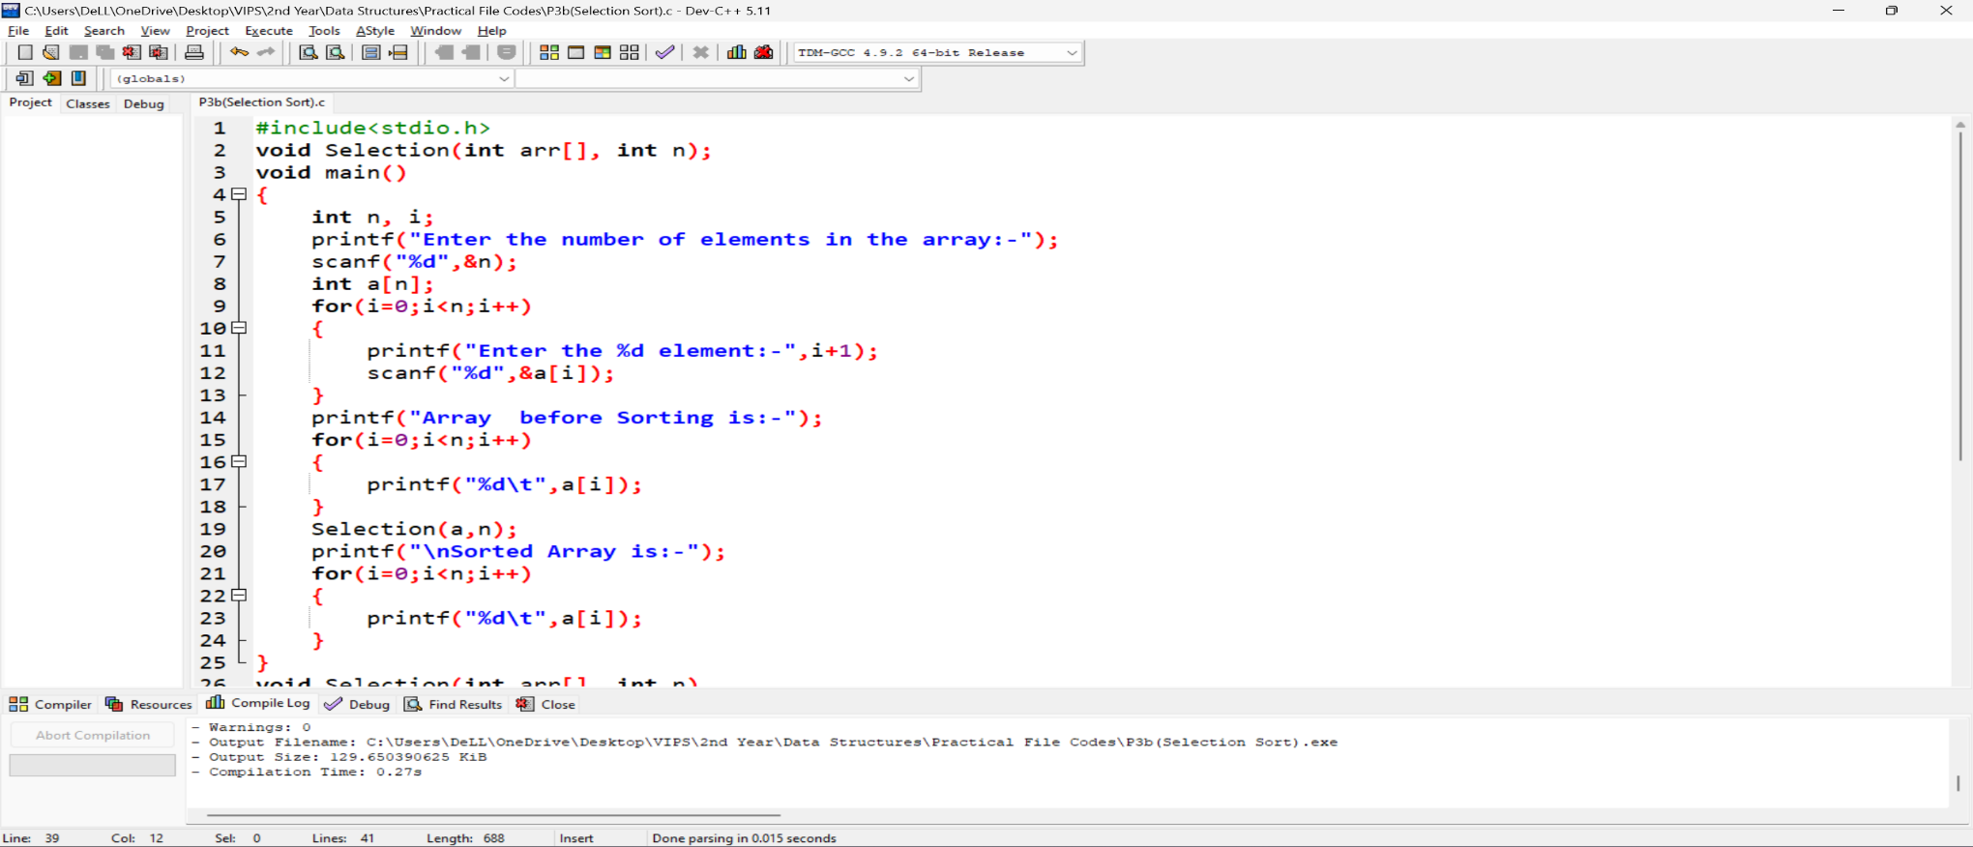**Programming Code:**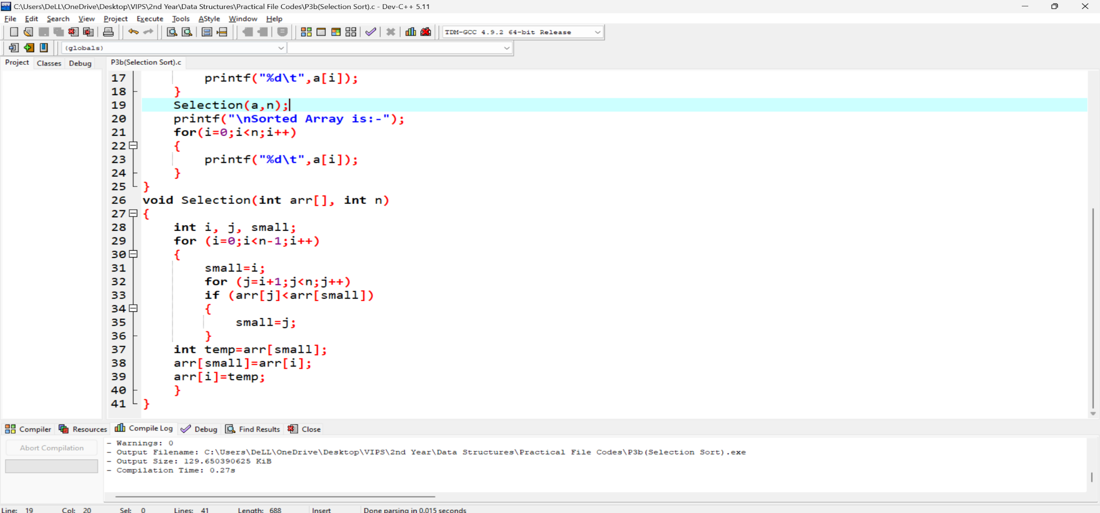

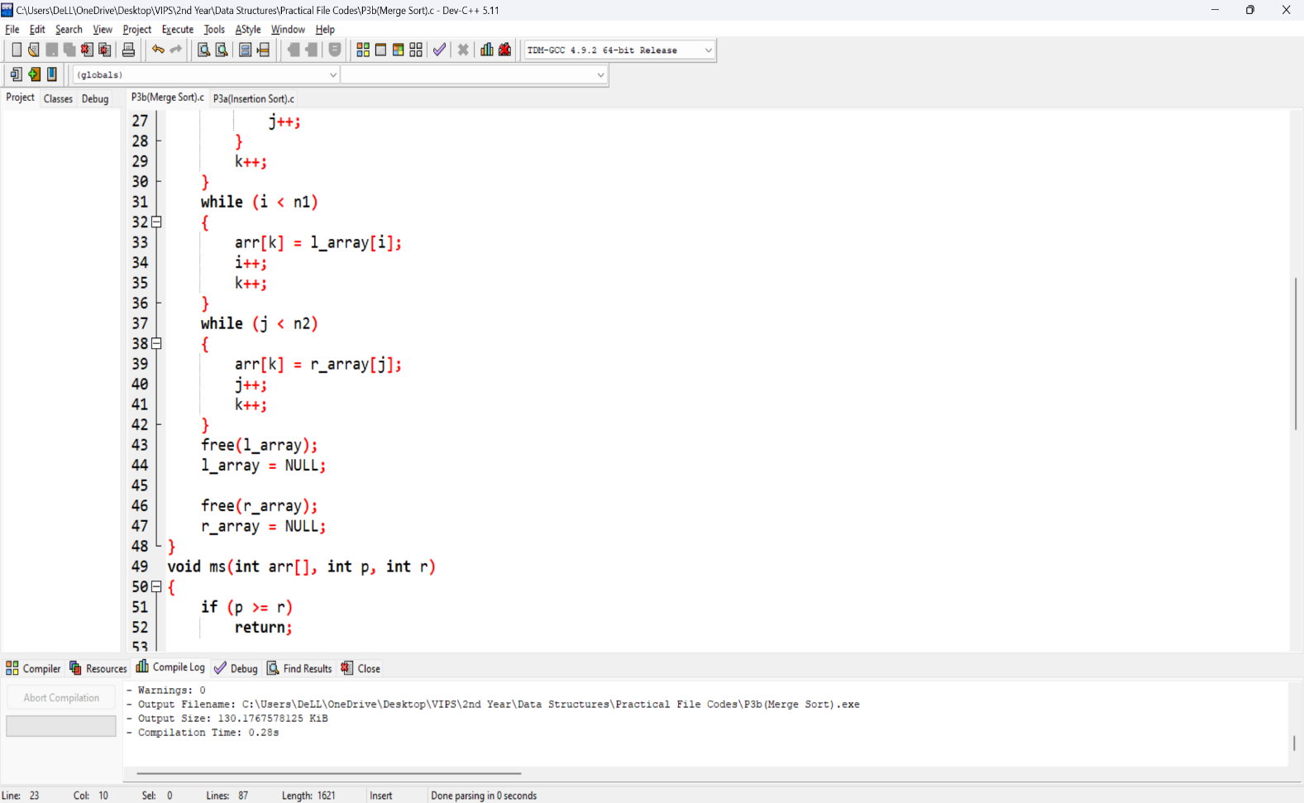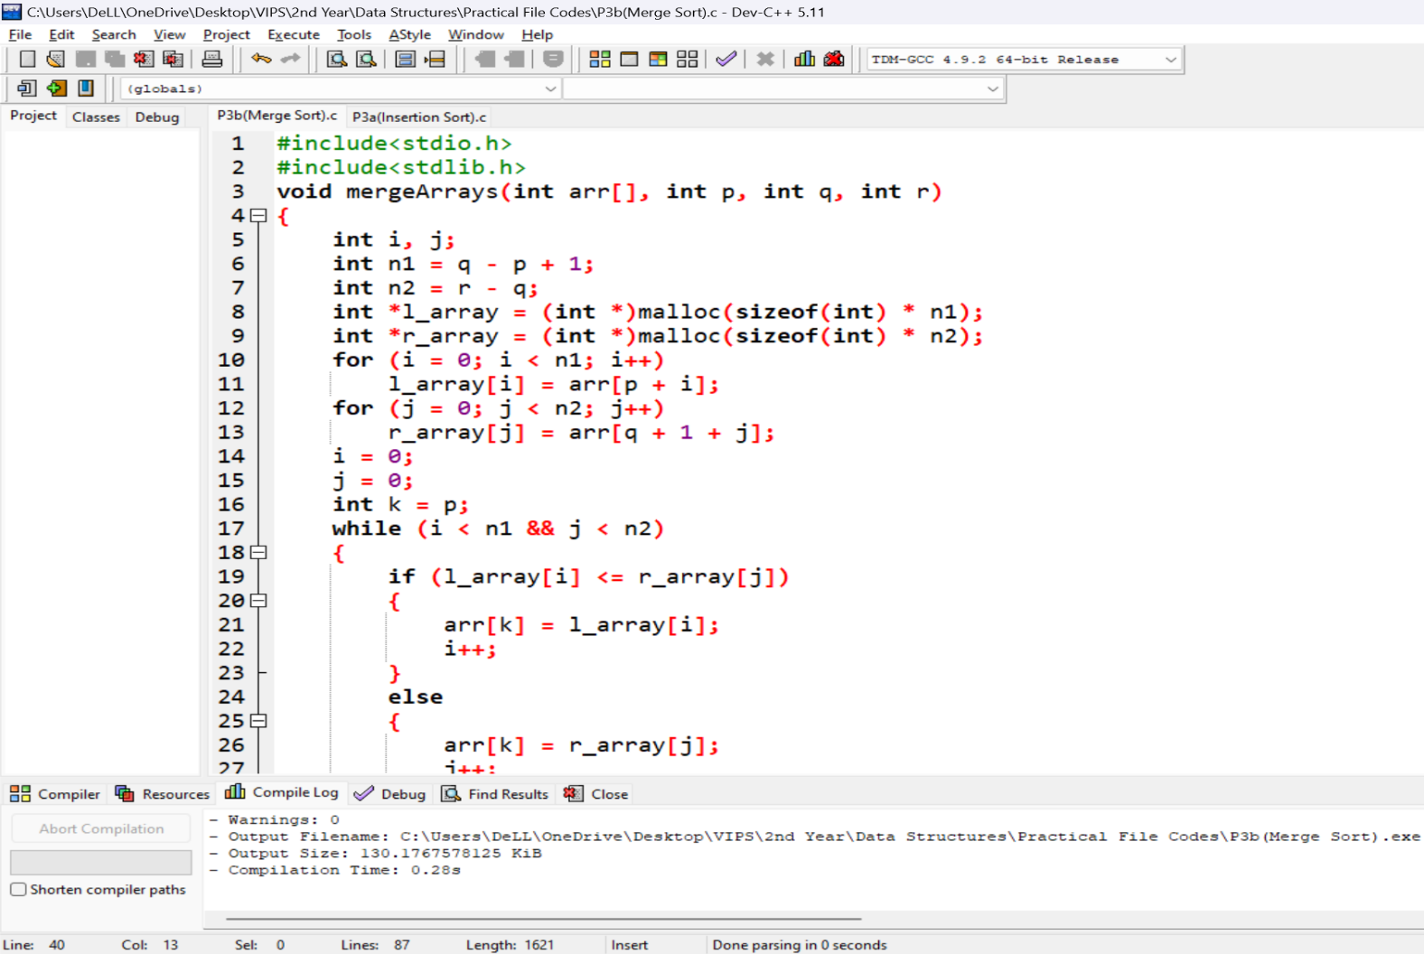

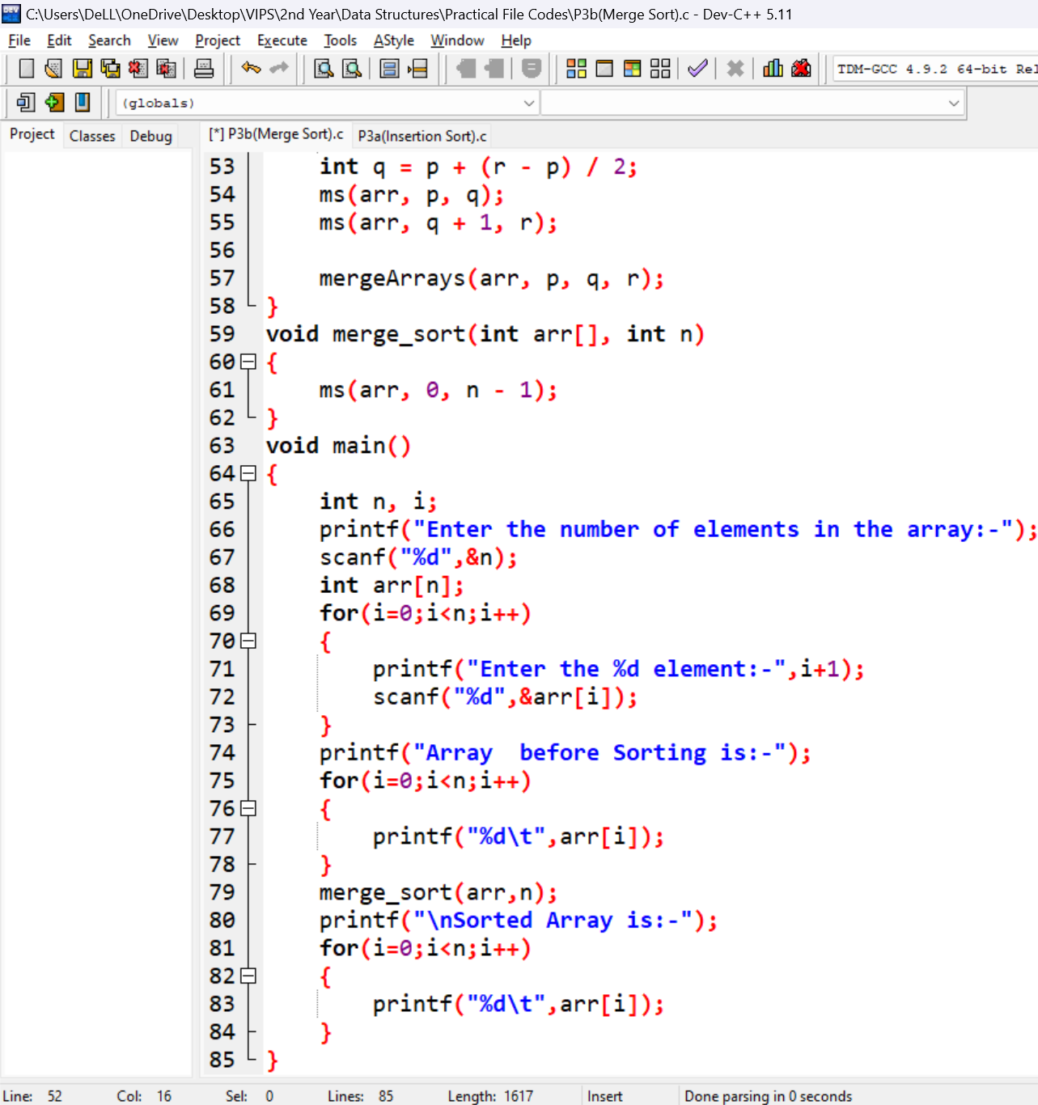

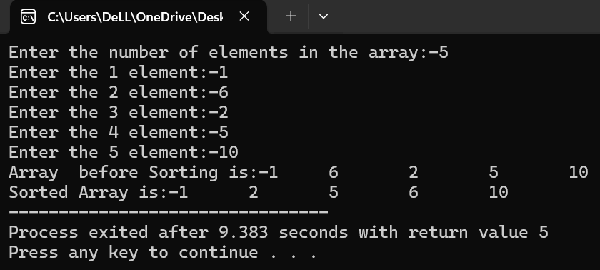**Outputs:**

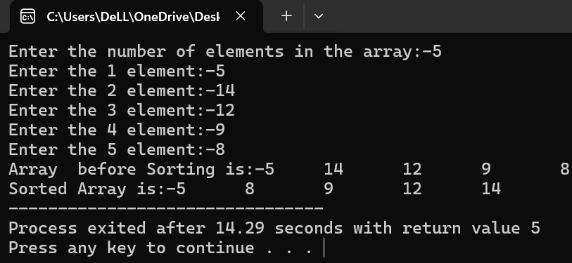**Learning Outcome:**

**EXPERIMENT 4**

**Problem statement:** Write a program to implement a Linked List using Stack and perform operations such as push, pop and display the list.

**Algorithm:**

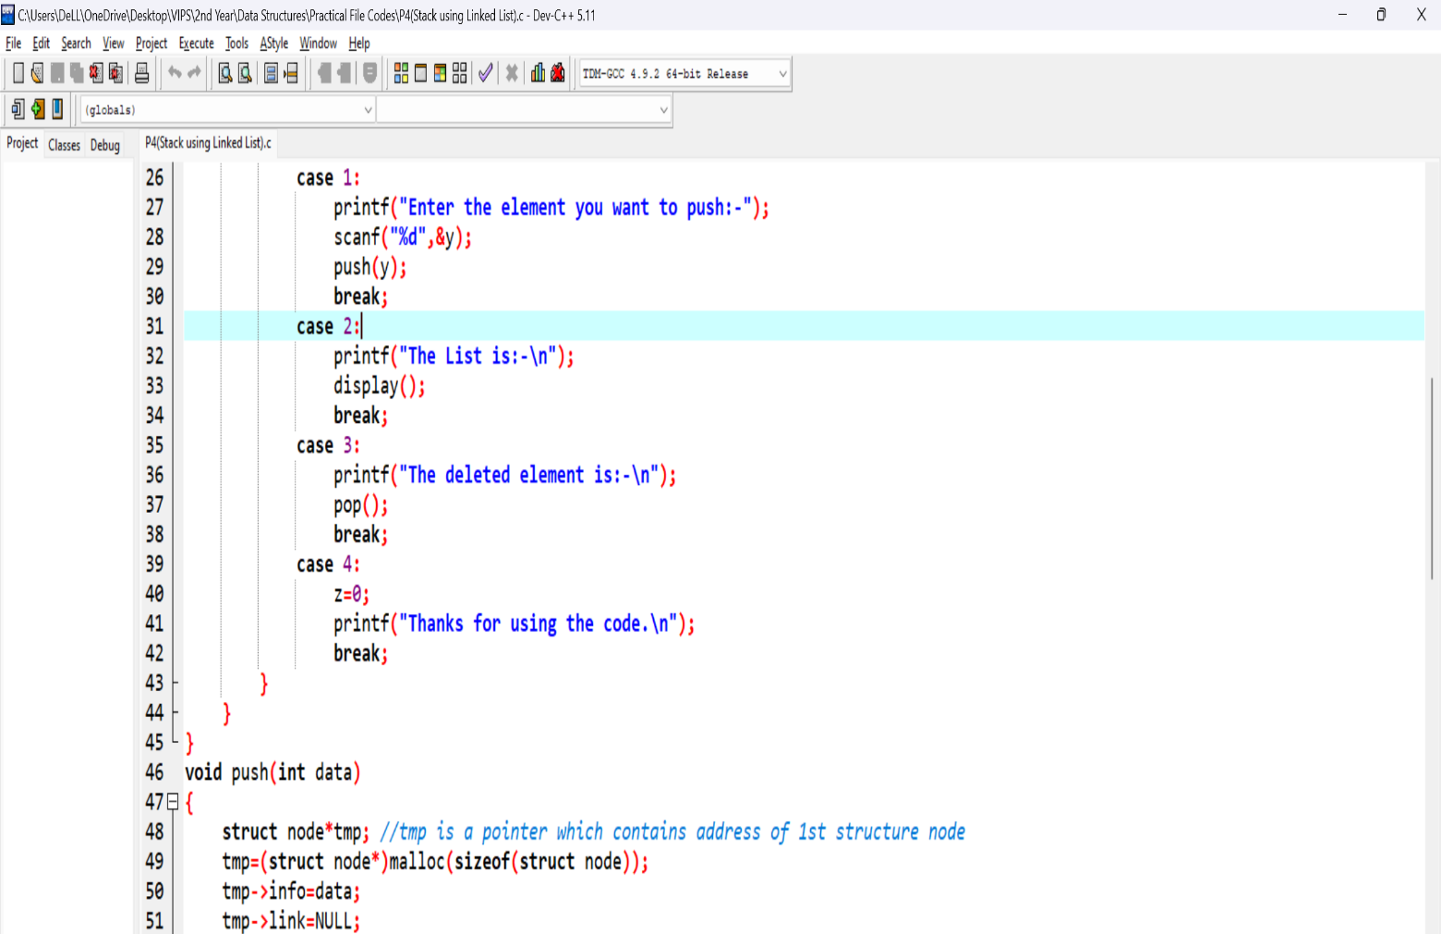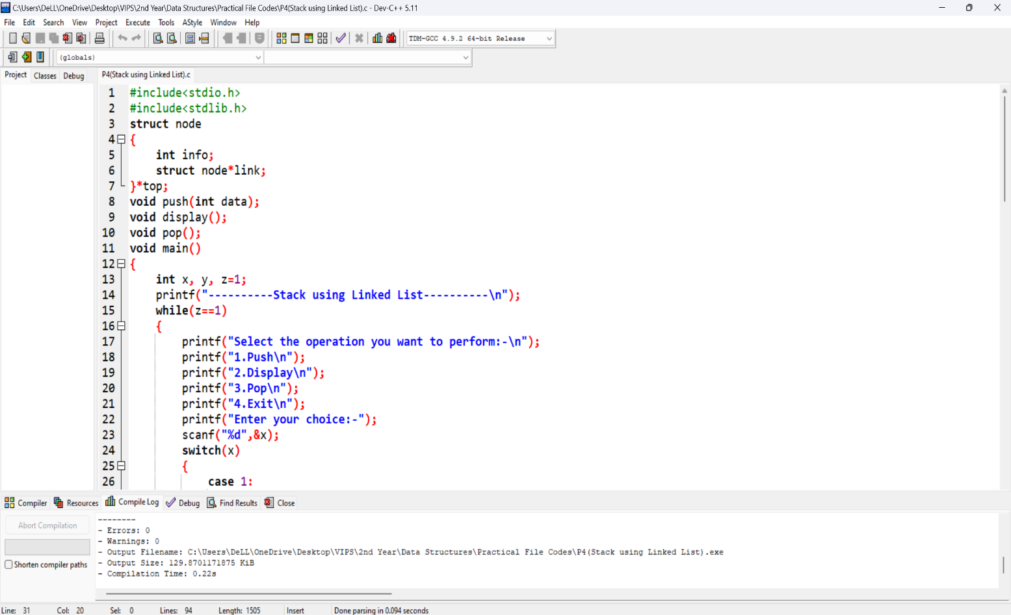**Source Code:**

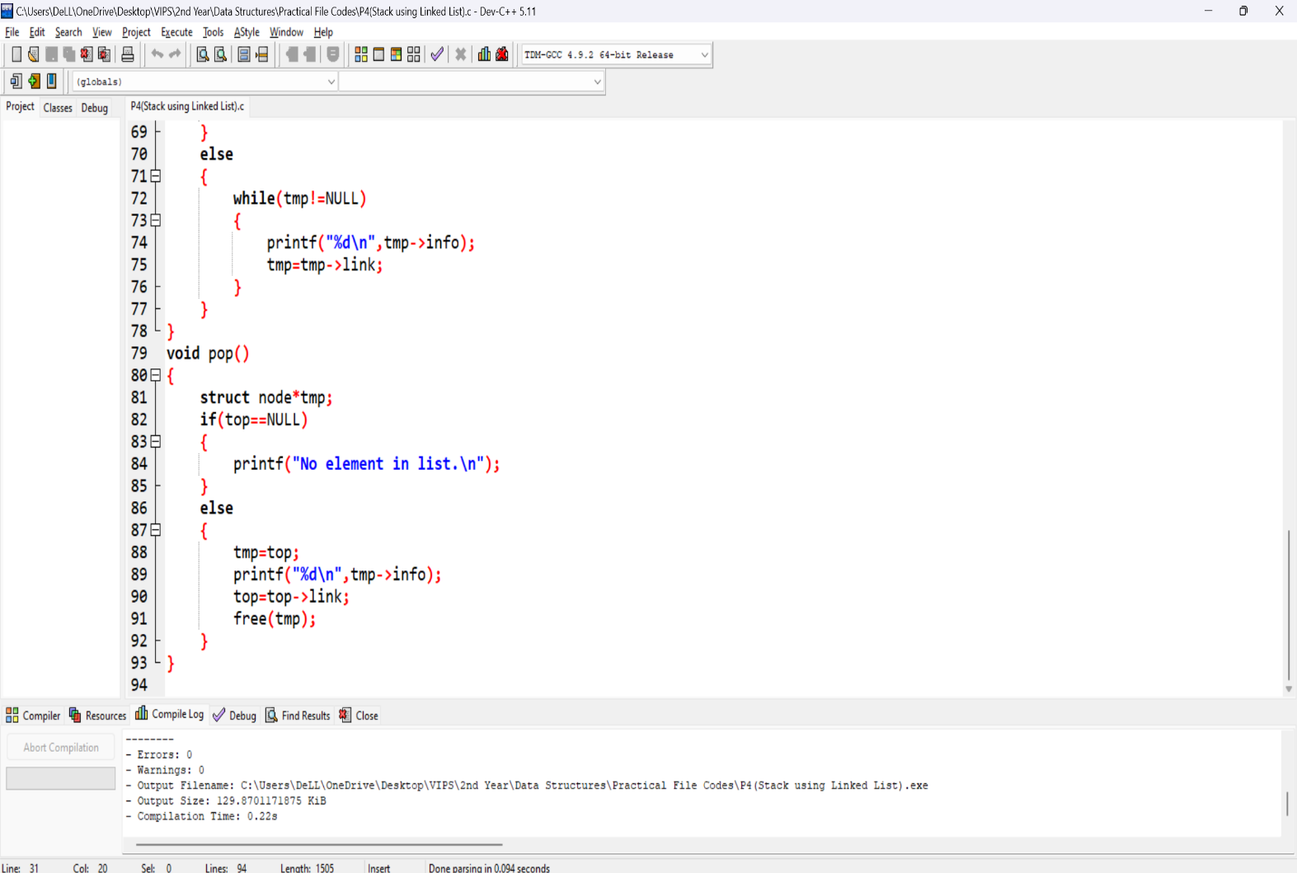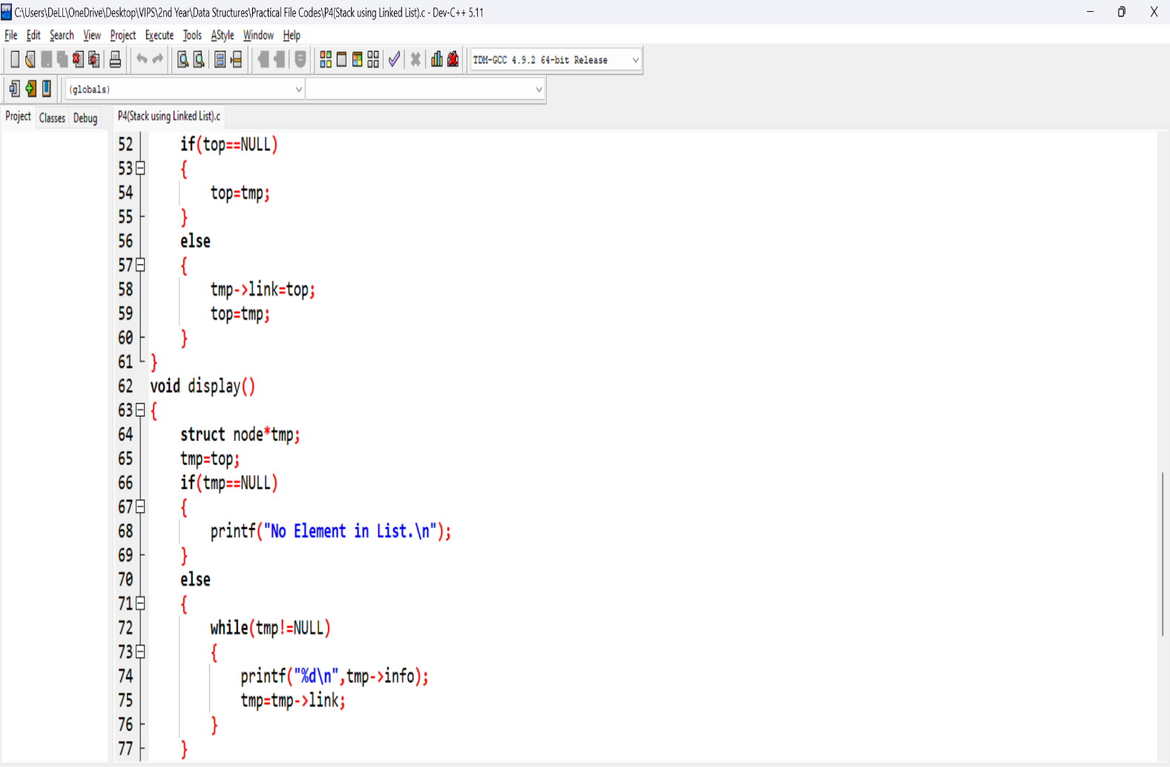

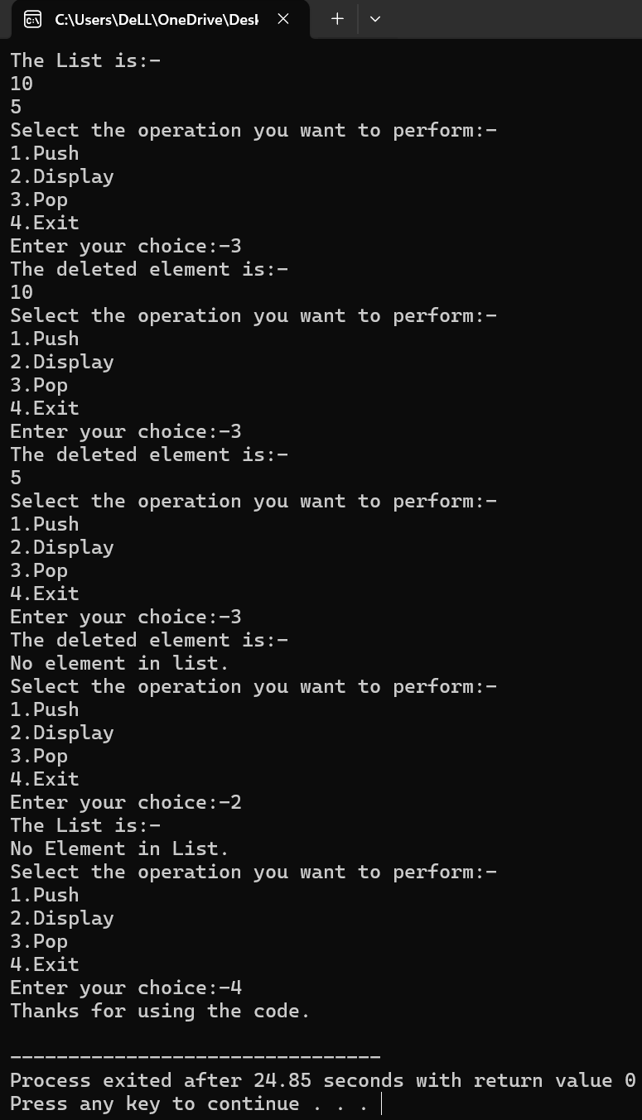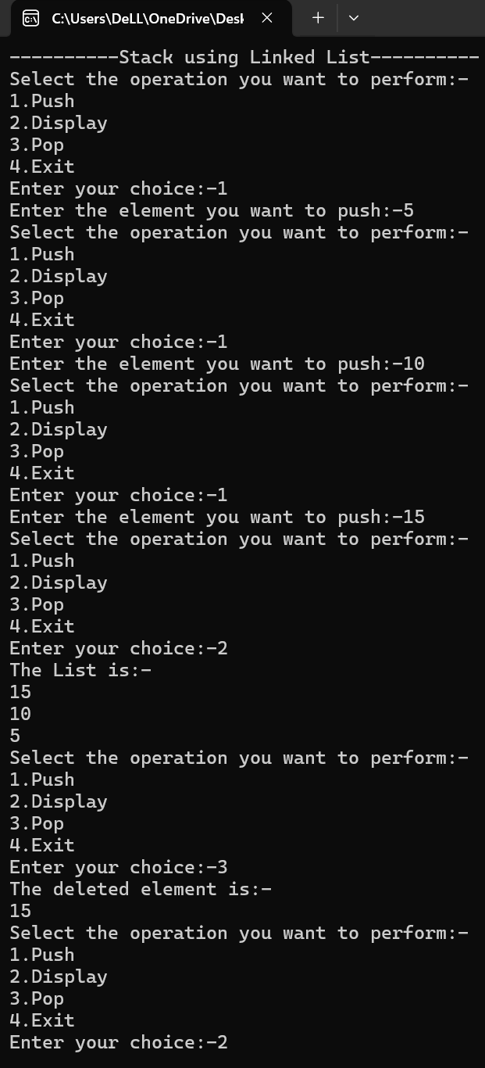**Outputs:**

**Learning Outcome:**

**EXPERIMENT 5**

**Problem statement:** Write a program to implement a Linked List using Queue and perform operations such as push, pop and display the list.

**Algorithm:**

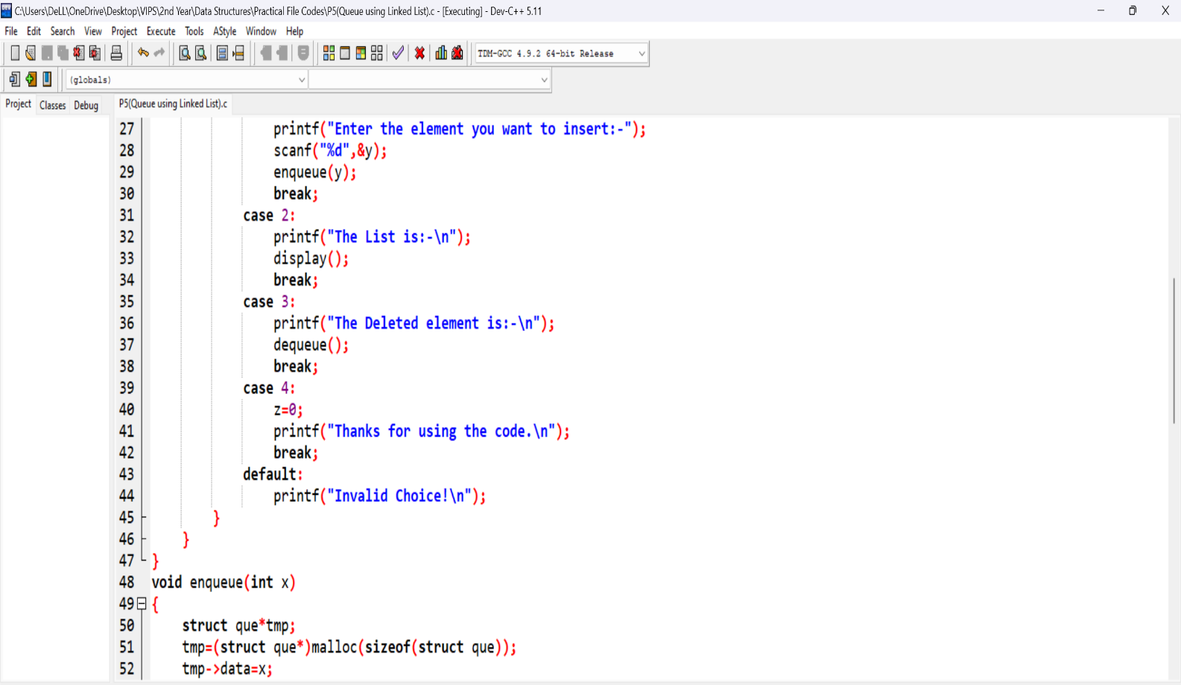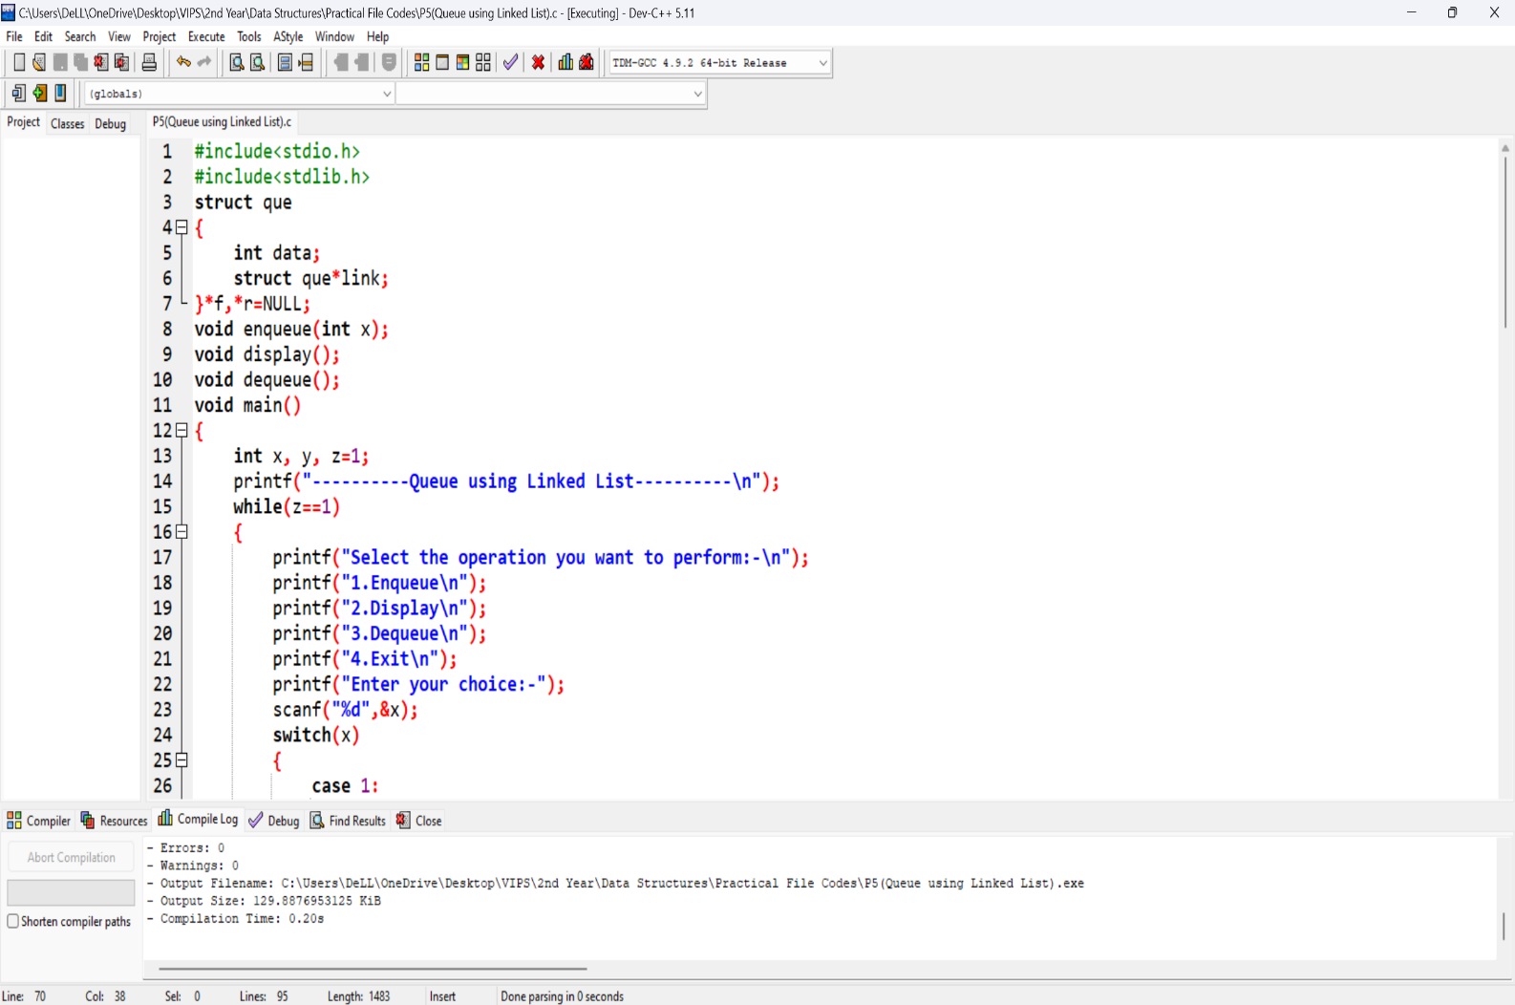**Source Code:**

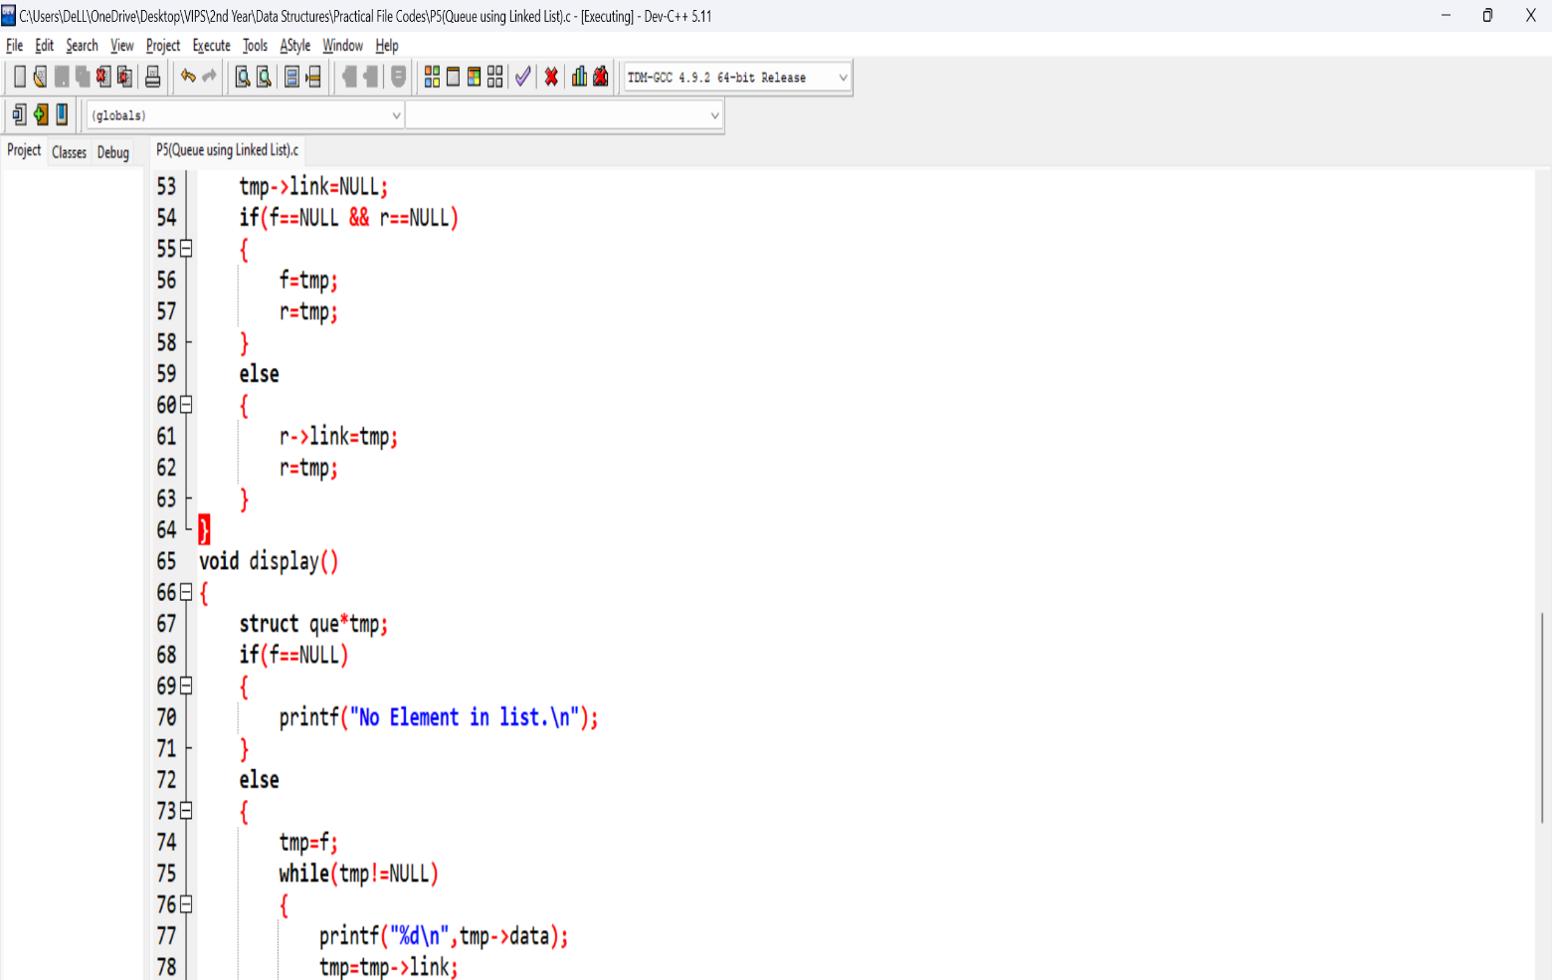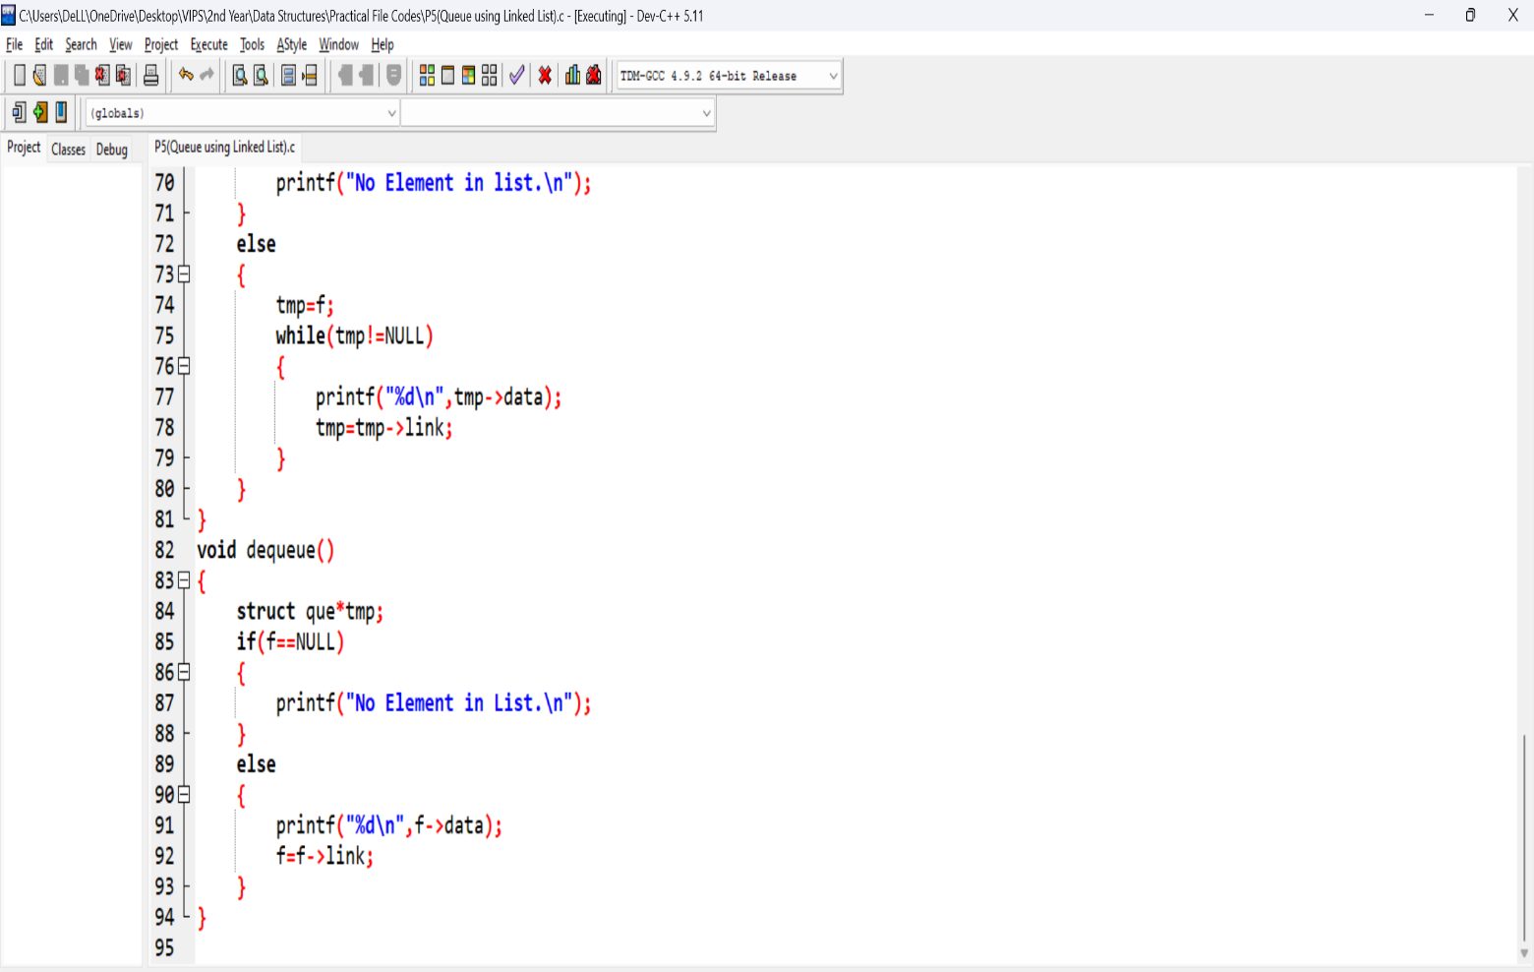

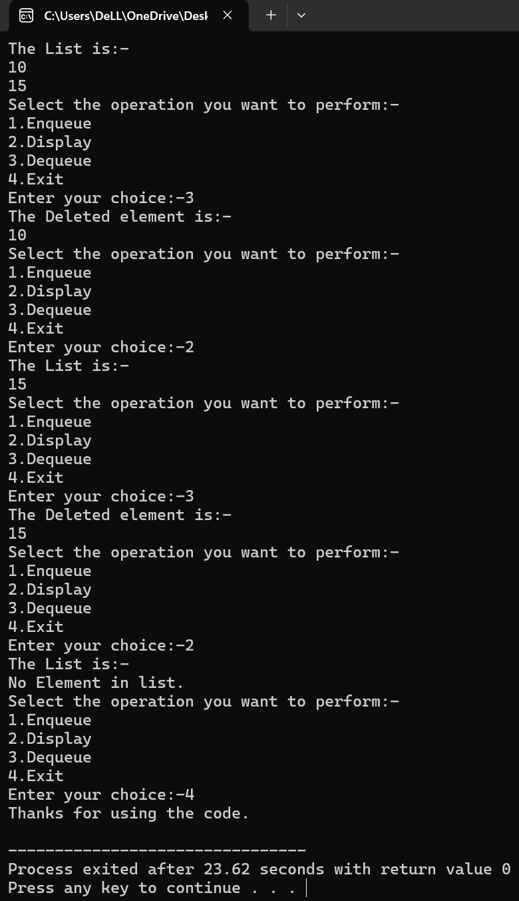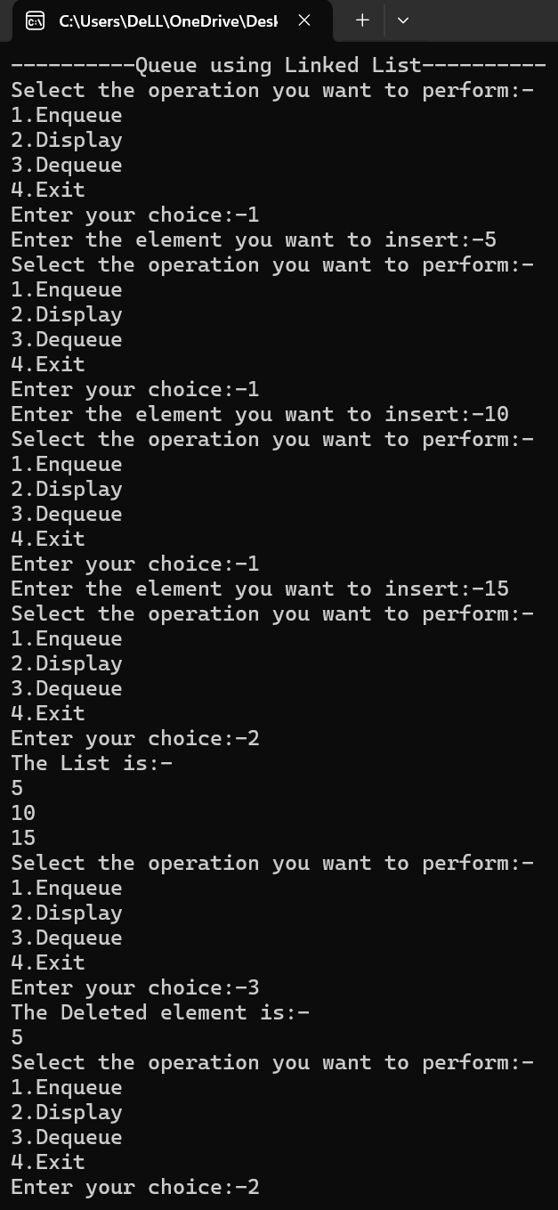**Outputs:**

**Learning Outcome:**

**EXPERIMENT 6**

**Problem statement:** Write a program to create a linked list with nodes having information about student’s name, branch, section and roll number. Also insert a new node at a position specified by the user.

**Algorithm:**

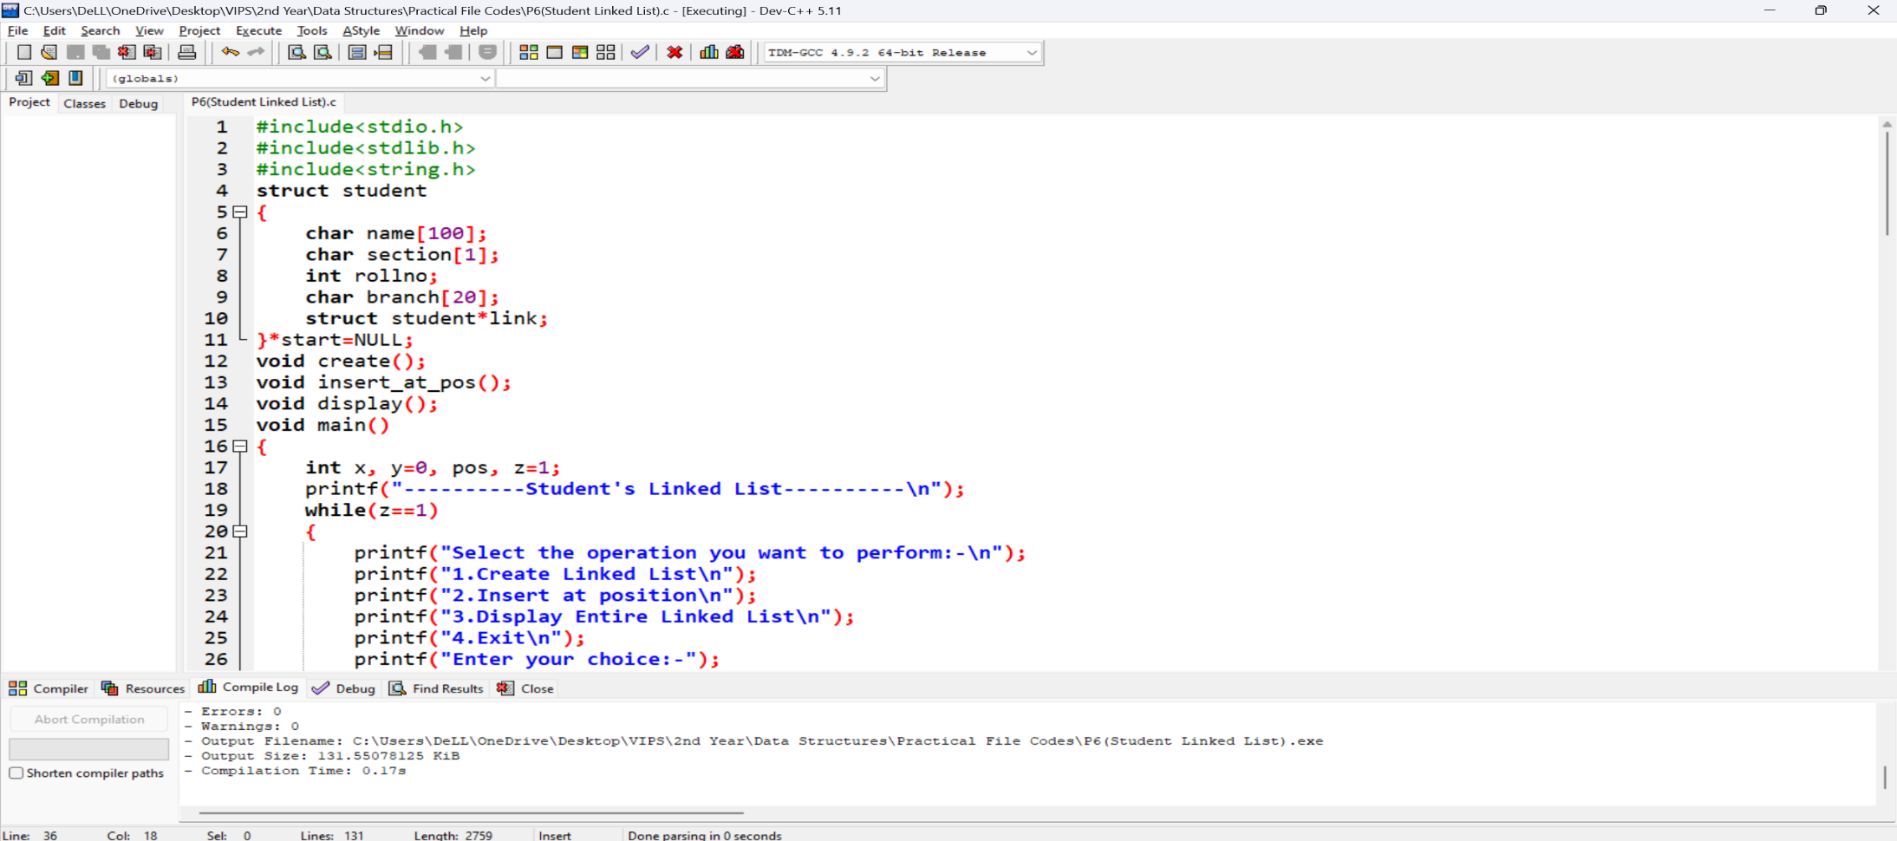

**Source Code:**

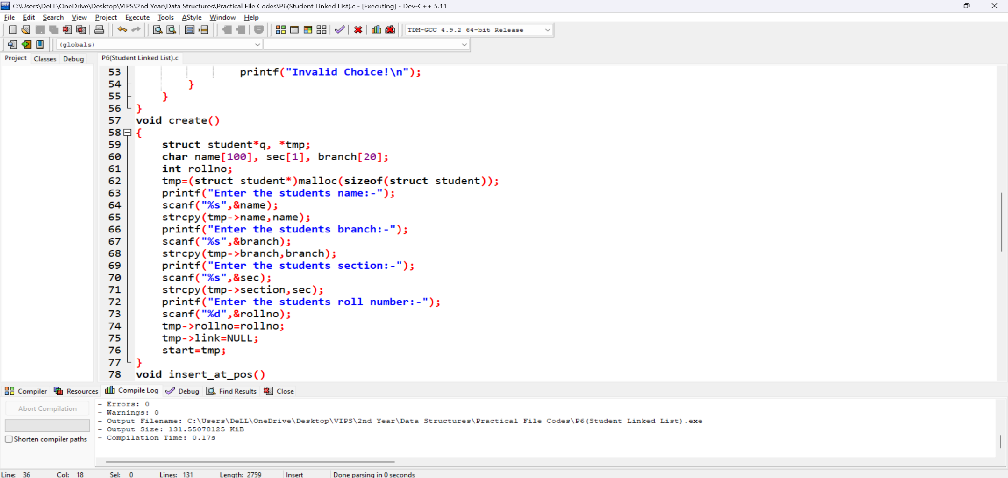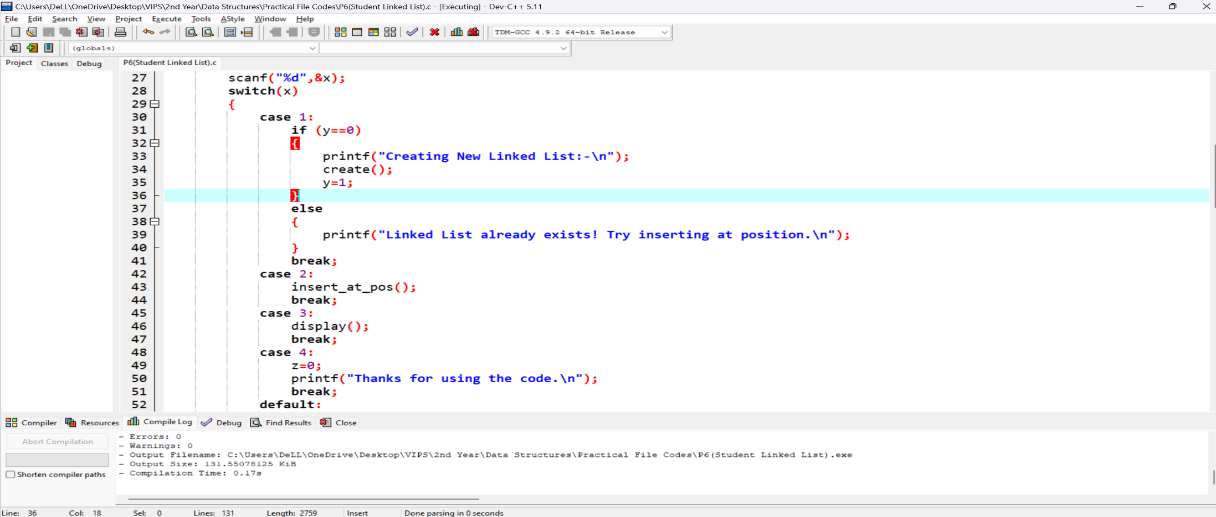

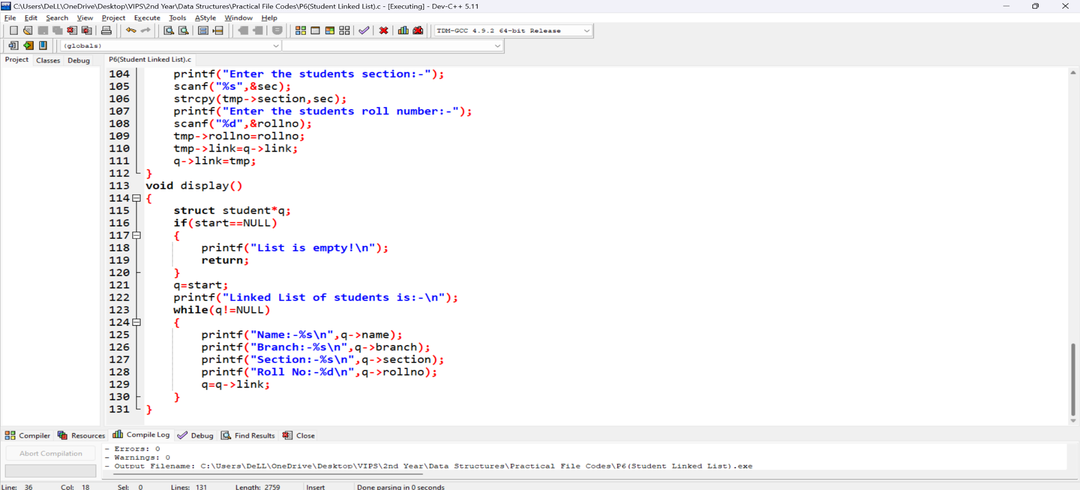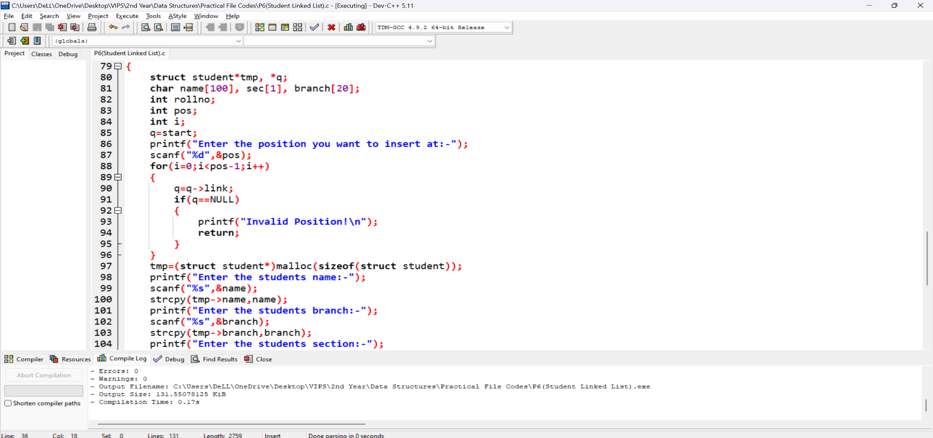

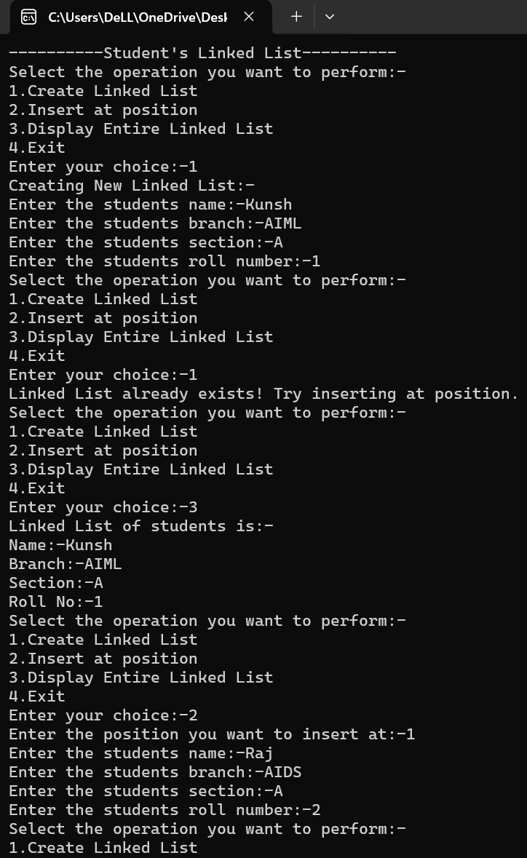**Output:**

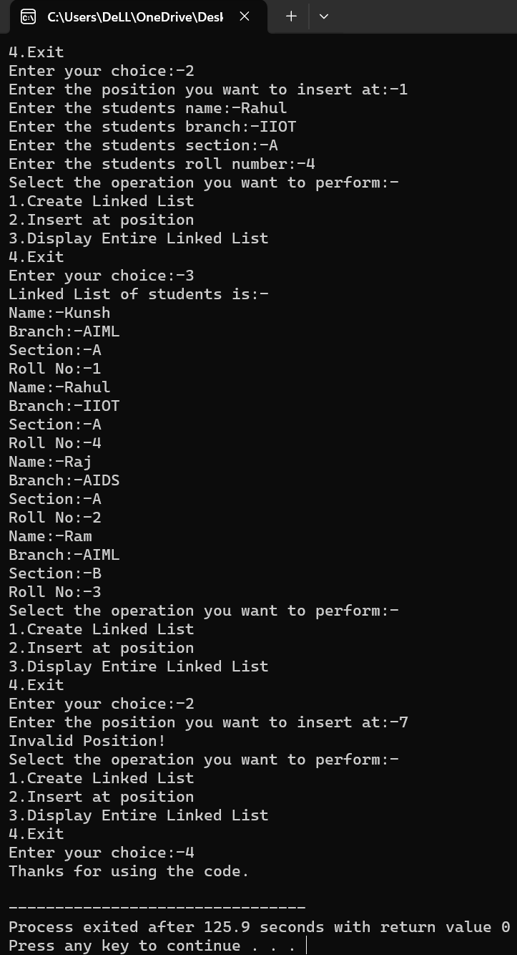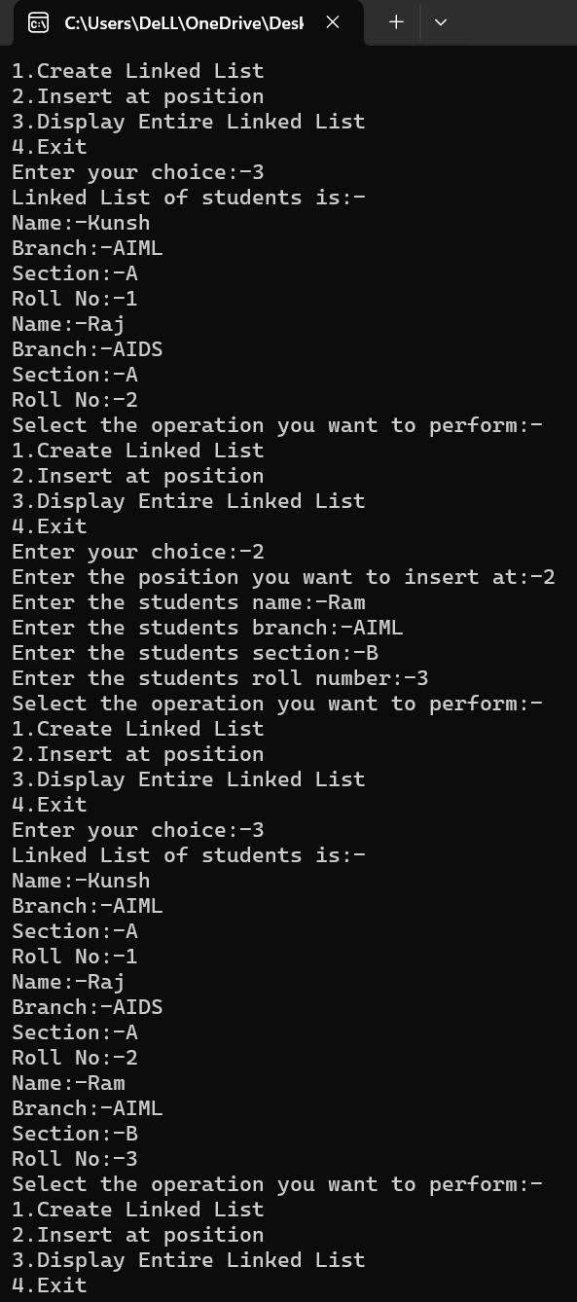**Learning Outcome:**

**EXPERIMENT 7**

**Problem statement:** Write a program to create a doubly linked list with nodes having information about an employee and perform insertion at front of doubly linked list and perform deletion at the end of that doubly linked list

**Algorithm:**

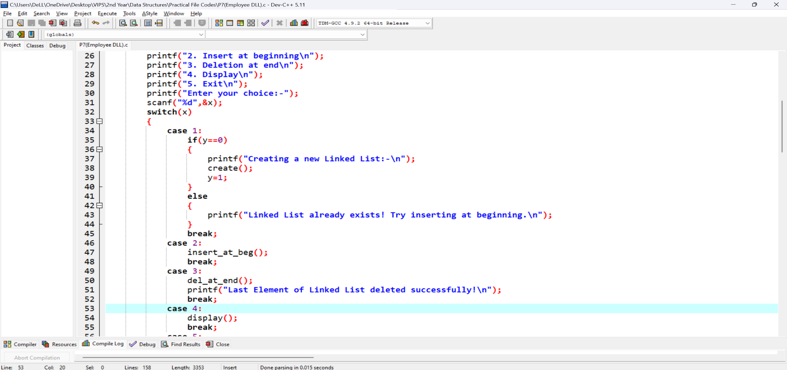**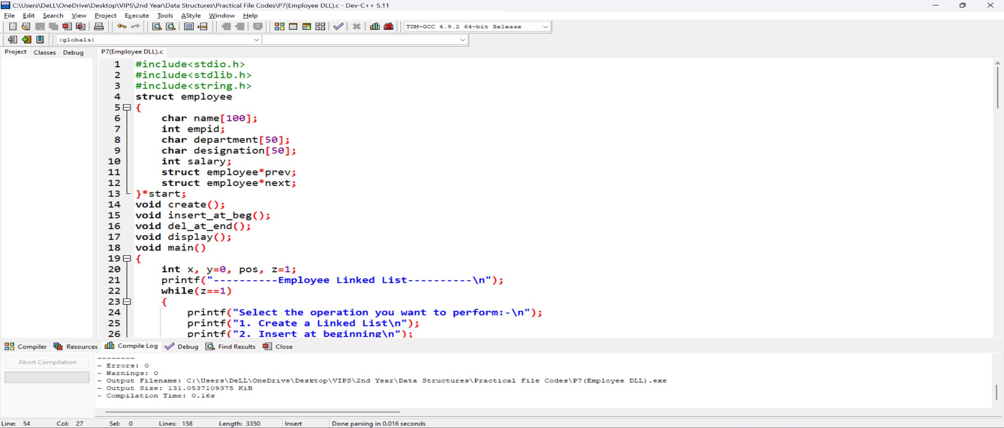Source Code:**

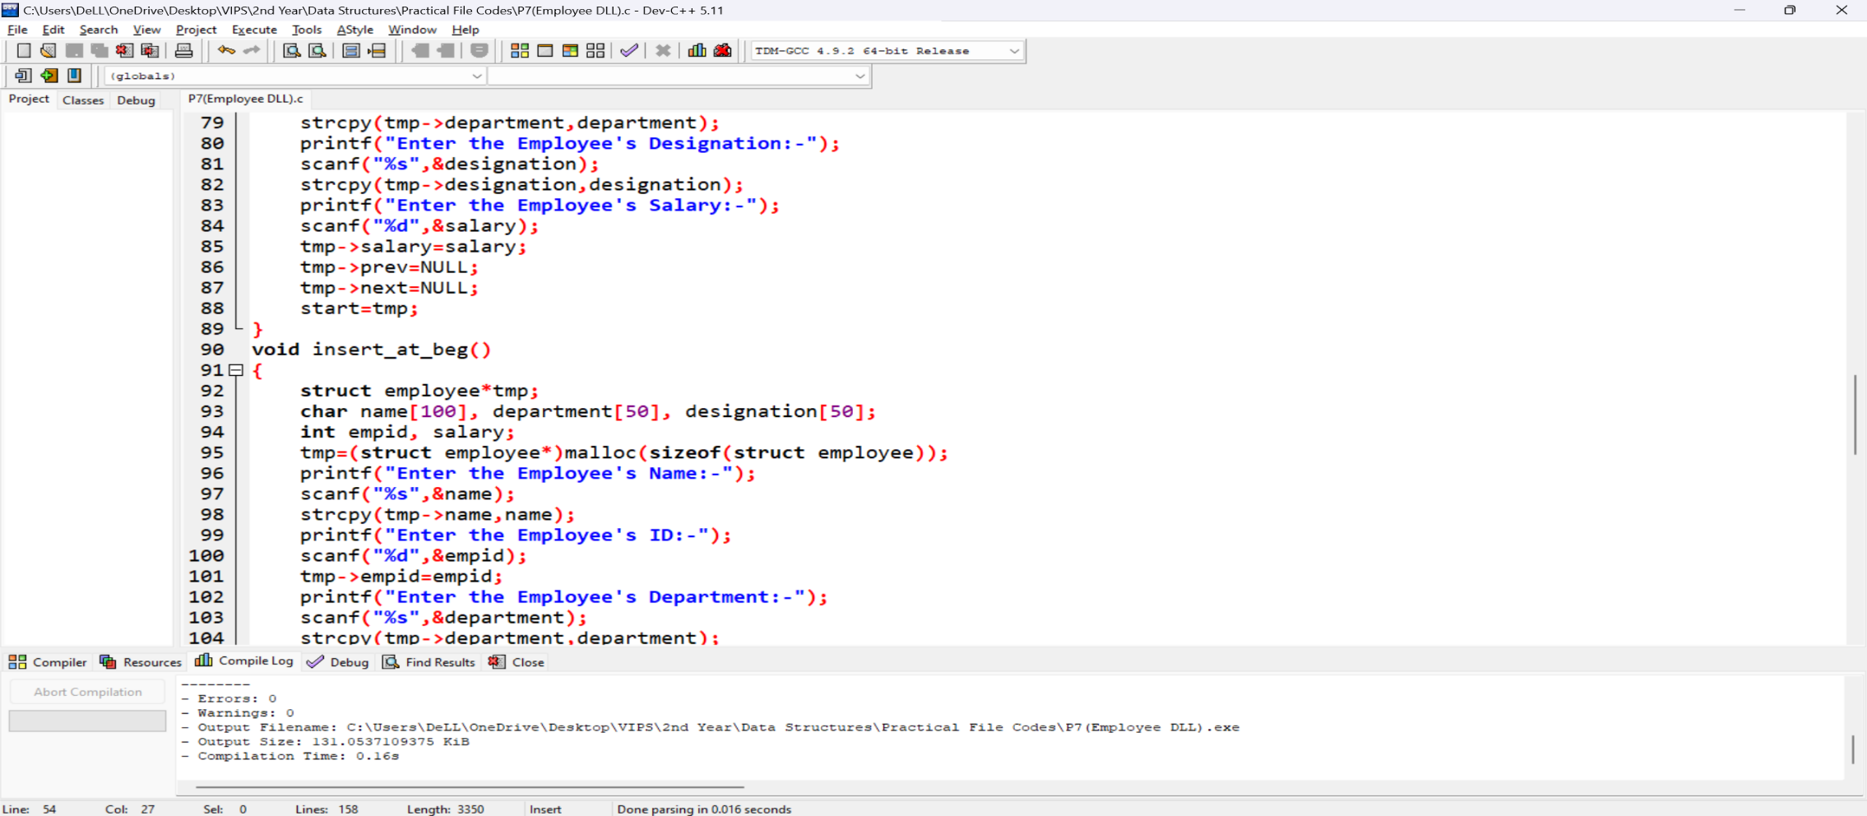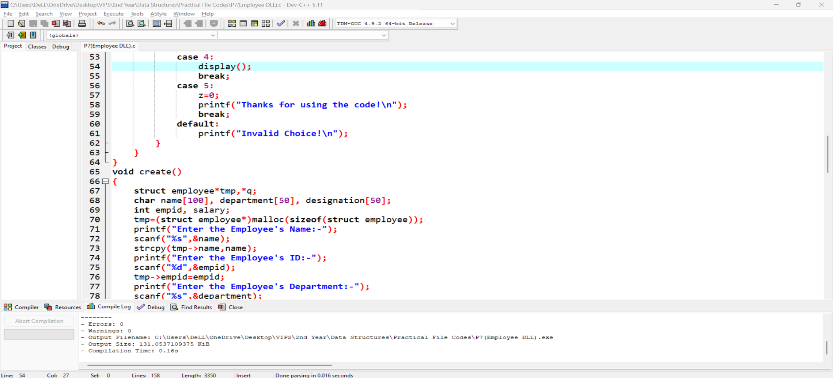

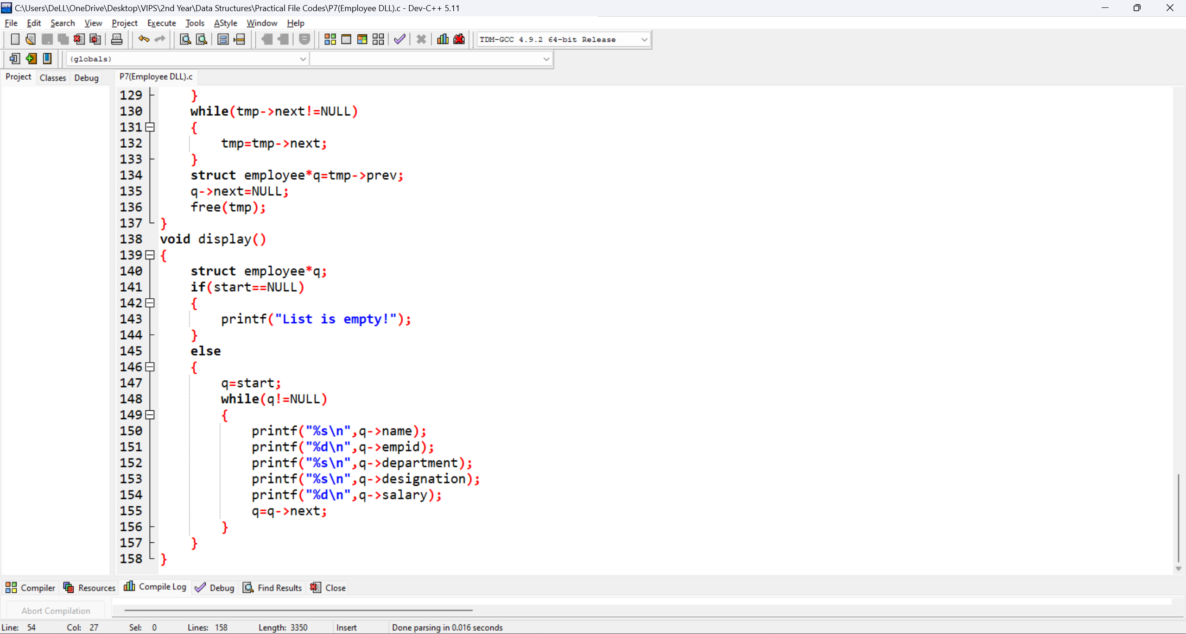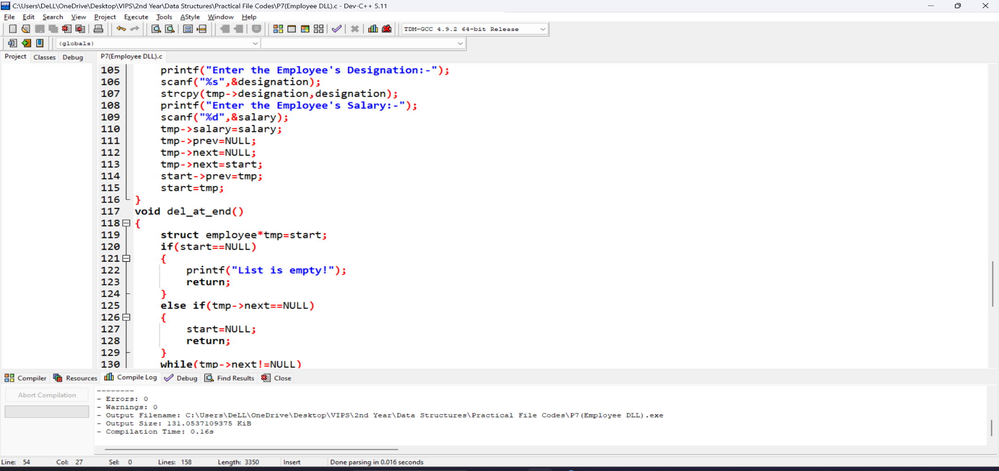

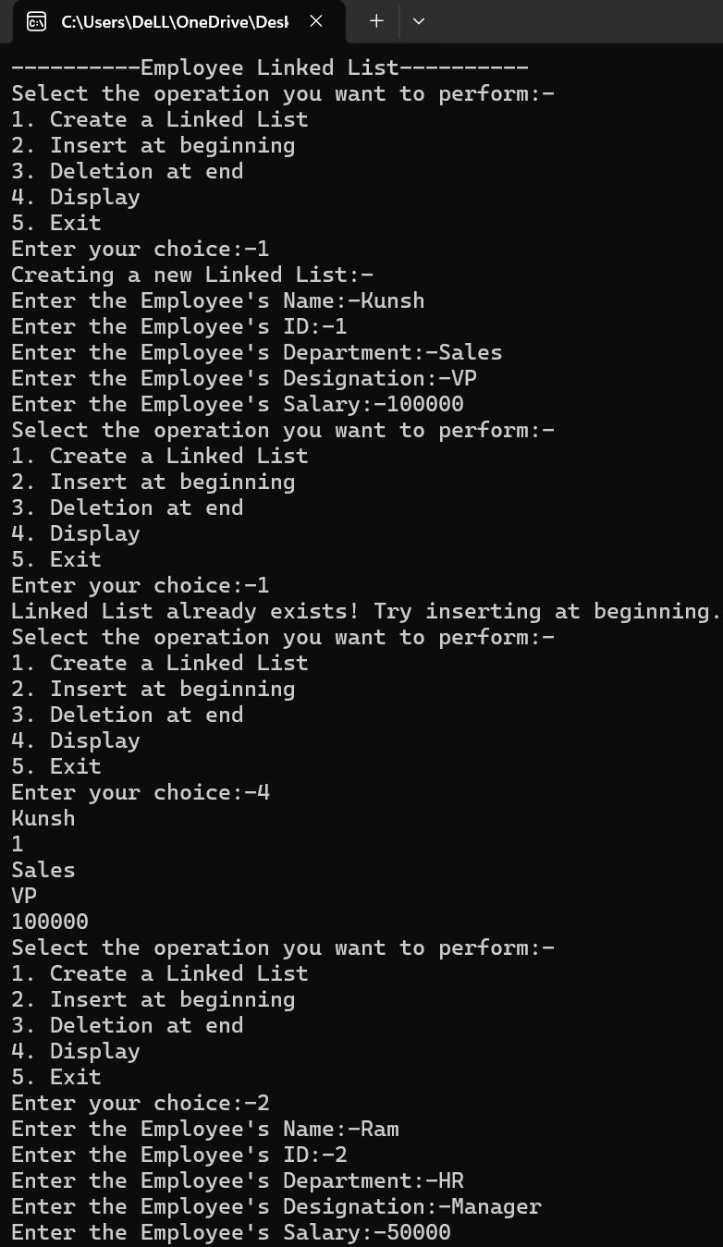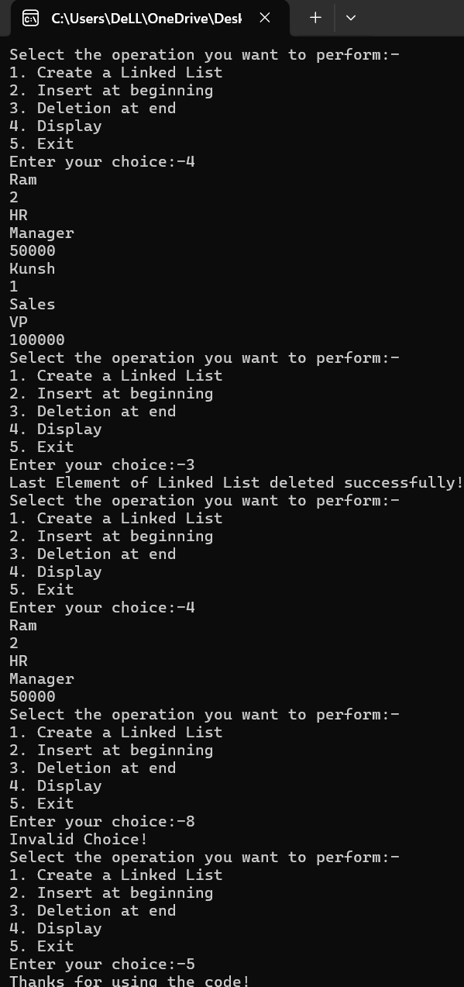**Output:**

**Learning Outcome:**

**EXPERIMENT 8**

**Problem statement:** Write a program to create a Circular Linked List having information about a college and perform insertion at the front end and perform deletion at the end.

**Algorithm:**

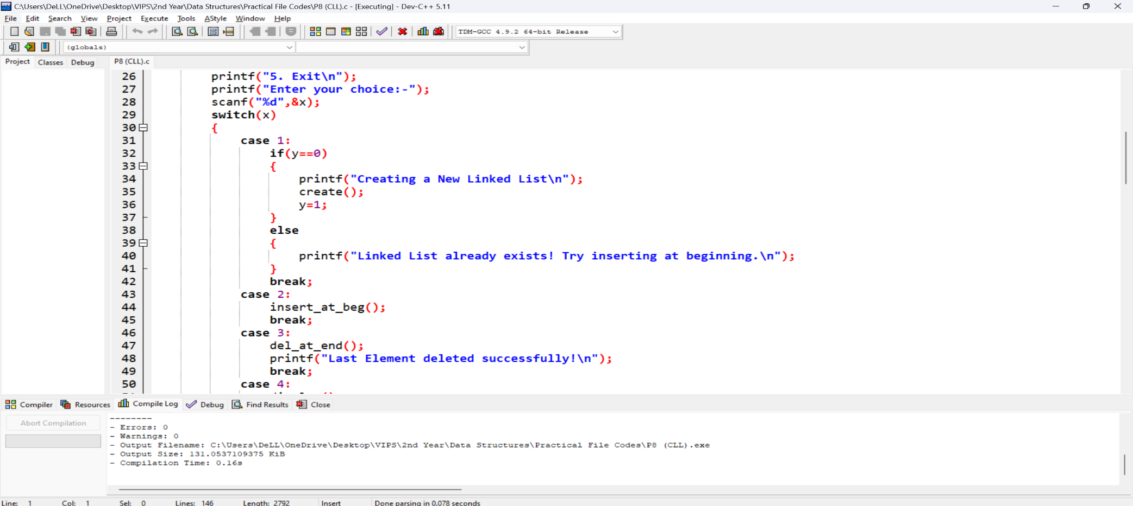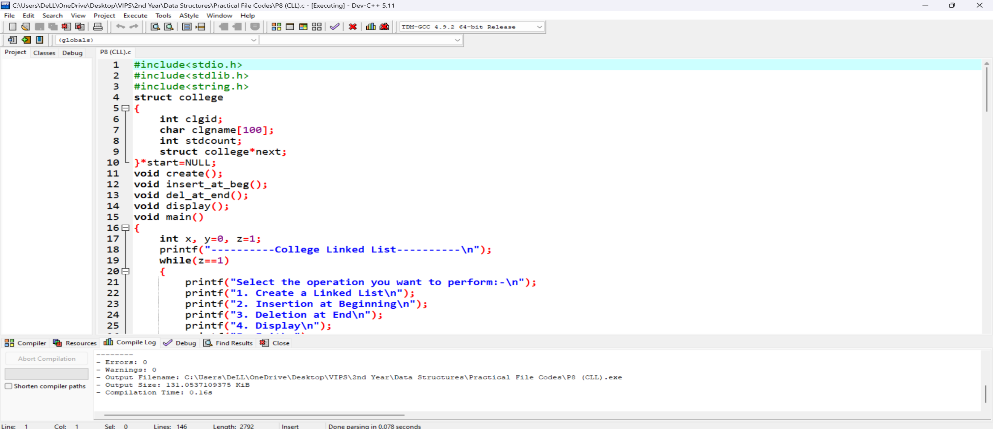**Source Code:**

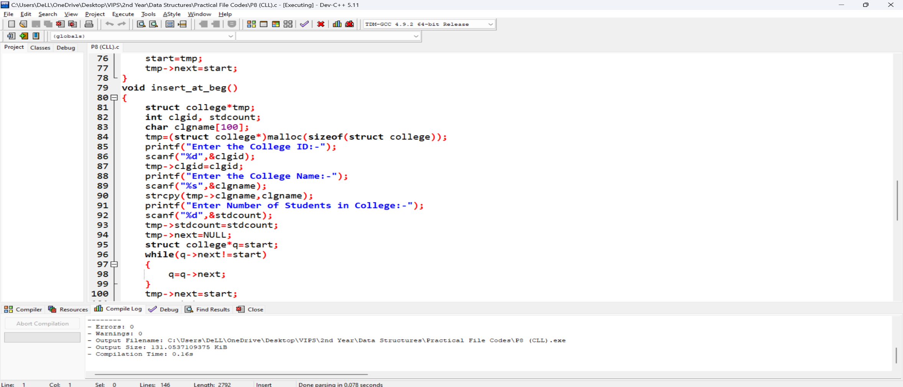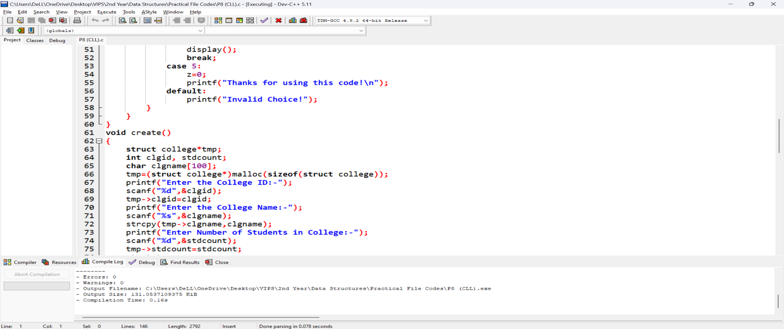

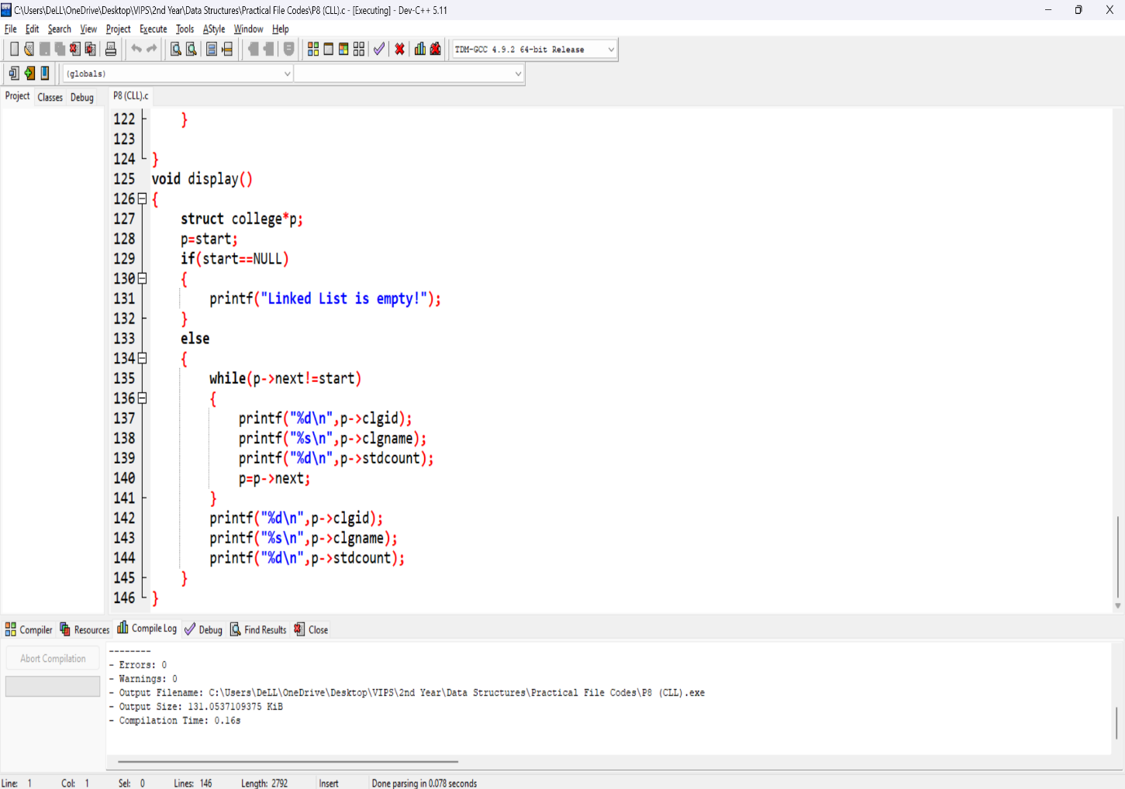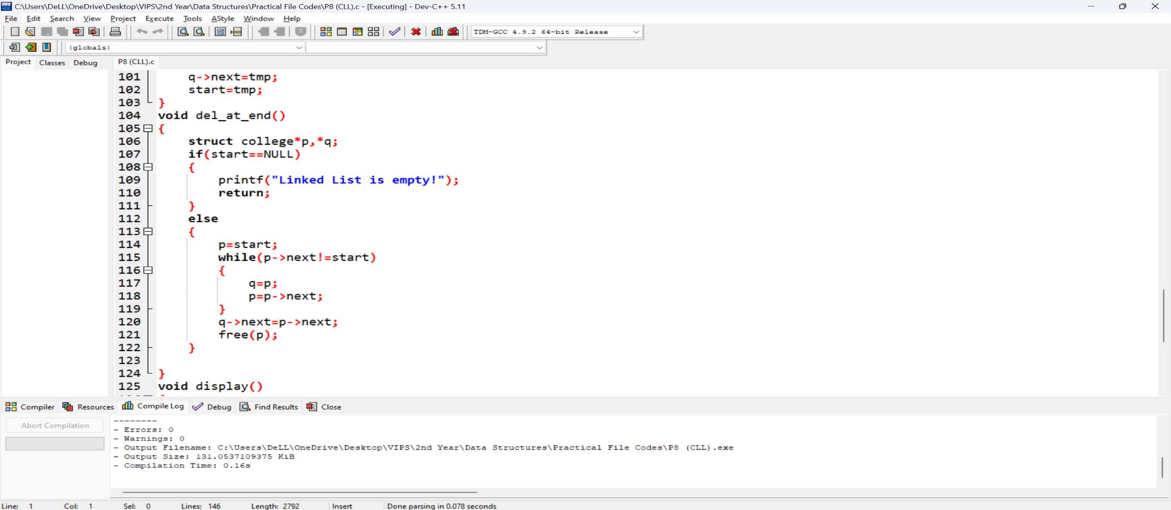

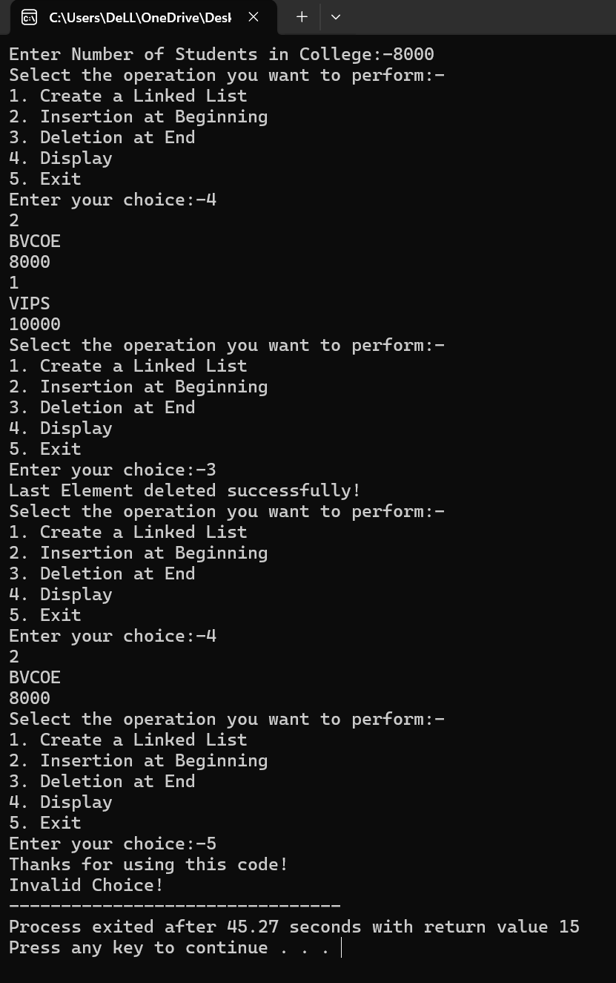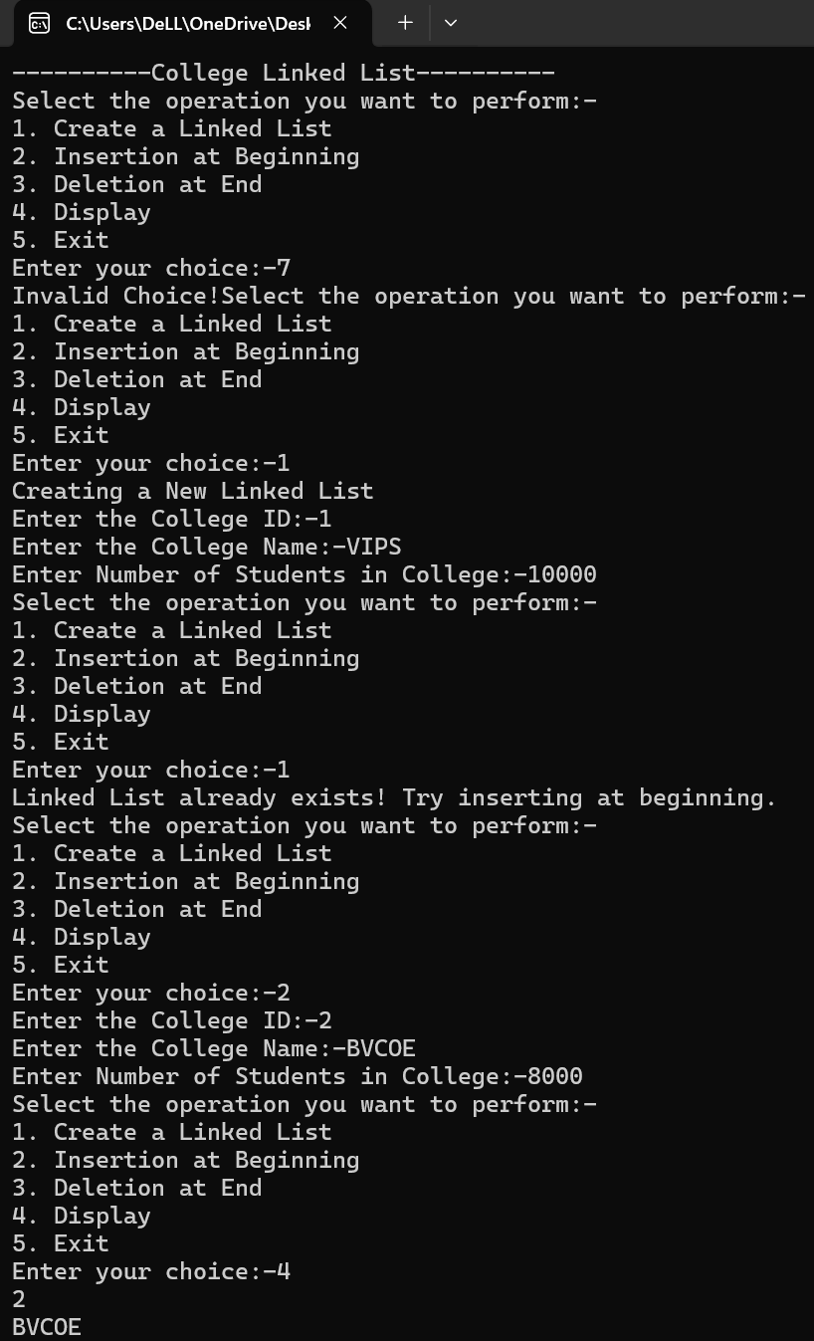**Output:**

**Learning Outcome:**